MASTER’S PROGRAMME IN GENDER STUDIES

MA HANDBOOK 2017

CENTRE FOR GENDER RESEARCH
UNIVERSITY OF OSLO

Content
Dear Students p. 3
Programme for new students 14-18th August p. 4
Important deadlines autumn 2017 p. 5
About the Centre for Gender Research p. 6
About the Master’s programme p. 7
Programme structure p. 8
Learning outcomes p. 8
Project outline: choosing your thesis topic p. 10
STK Vore Faculty`s research interest in brief: p. 11
Writing the Master’s thesis p.12
Fieldwork and financial support p.12
Ethical implications p.12
How to get a supervisor p.13
Schedule and work plan p.13
A semester abroad p.13
Study entitlement and study progress p.14
Career prospects p.15
Life around the studies p.15
STK Student Committee p.15
Appendices: Forms
I: Supervision Agreement p.17
II: Schedule and work plan p.20
III: Application for supervisor p.21
STKs contact information p. 22

Dear students,

Welcome to the 2017 Master’s programme in Gender Studies!
In this handbook you will find information about the programme your studies and the Centre for Gender Research.
To open the web links in this handbook, please access the digital version from the MA programme website (in English)
You may also find helpful information on the University’s dedicated pages for international students: http://www.uio.no/english/studies/new-student/

Good luck!

Helene Aarseth Helle P. Granum
Head of Studies Student Advisor

Programme for new MA students at the Centre:

Arrival and orientation week (14th – 18th August)
For full overview
http://www.uio.no/english/studies/programmes/genderstudies-master/

Tuesday August 15th
13.15 – ca. 14.00 (In Norwegian) A walk through the Blindern campus from a gender perspective with Ulla Uberg, Administrator of the University Art Collection; and Helle Granum
Meeting point: Outside Department of Physics http://www.uio.no/om/finn-fram/omrader/blindern/bl24/

Wednesday August 16th
09.15 - 12.00 Welcome and Introduction with head of studies Helene Aarseth and programme advisor Helle Granum. Information about the programme structure and suggested project resources. Lunch together with the “old” Ma students is served after the meeting.
12.15 - 13.00 MA Guidance sessions with programme advisor Helle Granum at STK, room 402

19.00 – MA Welcome Socials with 2nd year MA students at Vespa & Humla, Københavngata 2

PLEASE REMEMBER:
Sign up for your courses on Student Web
by 12 noon on Thursday August 17th!

Important deadlines autumn 2017/2018:

Course-registration:
Thursday August 17^{th:} Deadline for signing up for your courses. KFL4040, KFL4050 and one elective class https://www.uio.no/english/studies/programmes/genderstudies-master/elective-courses.html
on Student Web before12noon https://studweb.uio.no/as/WebObjects/studentweb2?inst=UiO
Monday August 21th: Check Student Web for admission to the classes
2018

Monday 2. April (2018): Deadline for a short abstract for your MA project, and apply for supervisor

ABOUT THE CENTRE

The Centre for Gender Research (STK) is a research unit at the University of Oslo, which aims to undertake interdisciplinary research, provide teaching and disseminate knowledge about gender studies, broadly defined. The Centre also supports and encourages gender research within the different faculties of the University.
The Centre was established in 1986 and is the largest gender research unit in Norway and among the largest in the Nordic countries.

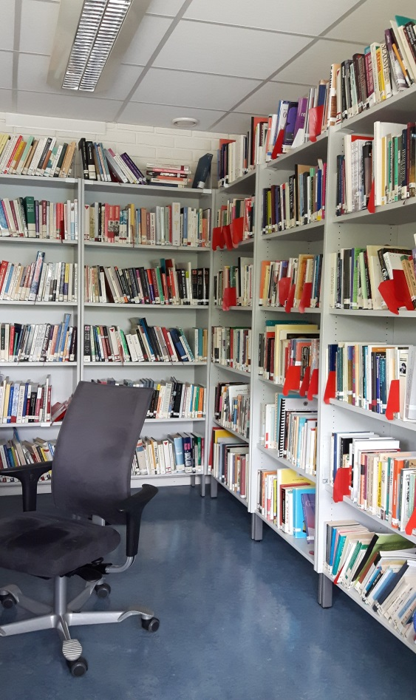 | The Centre attracts postgraduate students and researchers from all over the world, which ensures a dynamic and international community.  The STK offers a study library for its MA students. It consists of the Centre’s own library collection, computers and desks, and a lunch-and-rest area.  Our MA students are highly recommended to participate in the weekly Academic Lunch (Faglig Lunsj) on Thursdays at 11.30 in room 420, as well as in relevant research networks and activities.  During the academic year STK organises several seminars and conferences, which we encourage our MA students to attend.  A list of our upcoming events (in English) can be found on the Centre website, or click here

About the Master’s programme

The Master’s programme in Gender Studies was established in 2011. The programme is taught in English, is interdisciplinary, and will enable students to gain and broaden their knowledge in the field of gender studies, as well as develop the ability to work independently on central issues related to gender, feminism, gender equality, power, and knowledge production. A central programme focus is to examine the use of gender as an analytic category, with a critical perspective on central questions within science, politics, culture, society, and the arts.
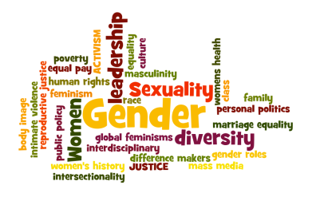
The programme consists of six courses (60 credits) and a Master’s thesis (60 credits), for a total of 120 credits. In the first semester of the programme the focus will be on the courses KFL4040 and KFL4050 and one elective course. In the second semester, the students will choose two elective courses at University of Oslo and KFL4000. The thesis is written during the second year of the programme (semesters 3 and 4) and should be finished by the end of the 4th semester. Students will write a thesis based on their own research, supervised by a member of staff and/or affiliated researchers. Students will select their thesis topic in the first and the beginning of the second semester. The elective courses may be in English or Norwegian, and the thesis supervision is offered in both English and Norwegian depending on the student’s language proficiency. The thesis can be written in English, Norwegian or any other Scandinavian language.

This is an interdisciplinary and flexible programme where students have the option to combine gender courses at the Centre for Gender Research with courses from other University units. In their study programme students progress from working with general and basic themes, through courses that provide specialisation and knowledge of new areas, culminating in a period of independent research and writing the Master’s thesis. The courses in the first year of the study programme are, directly or indirectly, intended to assist the students prepare for their thesis research and writing. In the second year students will concentrate on their thesis research and writing. The topic for the Master’s thesis must be chosen in agreement with, and be approved by, the thesis supervisor/s and the Centre. Supervision includes assistance with developing the thesis topic, finding relevant literature, formulating the main research questions, finding source materials, and help with structure and presentation.

Programme structure
4. semester | KFL4090 - Gender Studies Master‘s Thesis
3. semester | KFL4090 - Gender Studies Master‘s Thesis
2. semester | KFL4000 - Interdisciplinary Research Methodologies and Thesis Writing Course for Gender Studies | *Elective course/preparing for thesis | *Elective course/preparing for thesis
1. semester | KFL4040 - Feminist Theory | KFL4050 - Theorising gender equality | *Elective course/preparing for thesis
 | 10 ECTS | 10 ECTS | 10 ECTS
*Elective course means courses that are relevant for their Master’s Thesis. All compulsory courses in the Master’s degree are taught in English, but students have the option to choose courses taught in Norwegian as elective courses.
https://www.uio.no/english/studies/programmes/genderstudies-master/elective-courses.html

Learning Outcomes

By the time you have completed the Master’s programme in Gender Studies, you will have gained the following knowledge, skills and general competence:

Knowledge
- advanced general knowledge of the gender research field and its central issues;
- in-depth understanding of a specific gender topic (e.g. feminist ethics, gender and education, gender and ethnicity, gender in history, gender in literature, gender and sexualities, gender and work, gender and welfare etc.);
- solid knowledge of gender theories, methodologies and methods of data collection and analysis in gender studies (e.g. empiricist, standpoint and poststructuralist theories, interdisciplinary methodological approaches, text analysis, observation, interviews etc.);
- apply gender-sensitive perspective on new areas within the academic field;
- in-depth understanding of feminist critique of science;

Skills
- analyse a gender issue and place it in a societal and cultural as well as in interdisciplinary perspectives;
- work in an independent, thorough and critical manner with central issues, research literature and empirical studies on gender;
- conduct independent research on issues in a gender perspective;
- understand the need for adherence to ethical norms; for critical assessment of data sources, and for limited research objectives in order to give an independent contribution to gender research;

General competence
- use insight into gender issues and processes in general to analyse specific gender problematics;
- see the connection between the theme and angle of a research project within gender studies and choice of methodology;
- communicate and discuss research-based knowledge on gender issues with researchers and lay people with an advanced level of written and oral proficiency;
- contribute to creative interventions that may result in a world with less inequality.

The Project Outline: Selecting your thesis topic
To ensure that students will be matched with suitable supervisors, we require that you submit a short abstract (max. 300 words) on the MA project you wish to undertake to the head of studies (helene.aarseth@stk.uio.no) no later than 1 April 2018. This abstract shall be based on the extended project outline that is a work requirement in KFL4000.

The draft proposal should include:
- a short description of your research question/s,
- the kind of data/material you wish to examine or collect,
- your theoretical and methodological perspectives,
- reference to key-words listed in the description of the Centre’s research areas (see below),
- your disciplinary background.
To inspire you in selecting a suitable thesis project, we recommend that you consider the current main areas of research at the STK. We recommend that you use the following list to select relevant keywords for your project interests and as indicators of a suitable supervisor.

STK Core Faculty’s research interests in brief:

For a comprehensive overview of all of our faculty members’ expertise and interests, please check their web profiles here

Anne-Jorunn Berg: Feminist theory, science and technology studies, racialisation and
whiteness studies, materiality, methodologies.

Beatrice Halsaa: Citizenship, women’s movements, equality, ethnicity, religion,
multiculturalism, political Participation.

Øystein Gullvåg Holter: Equality, gender equality theory, men, masculinities, feminist
theory, social class, democratization, work/care, the societal status of the sphere of reproduction, the history of ideas of gender equality, gender balance in education.

Harriet Bjerrum Nielsen: Gender and identity/subjectivity, children and youth, girls and boys, equality and education, psychosocial studies, subjectivities and social change, generations.
Jorunn Økland: Theology, religion and gender equality, feminism and sacred texts, women's religious leadership, cultural and linguistic translation of gender equality (on leave)
Helene Aarseth: Romantic relationships, love, parenthood, gender and class; practice theory (Bourdieu, Giddens), theories of modernity, critical theory, British psychosocial theories; qualitative methods, especially in-depth interviews and narrative analysis.
Elisabeth Lund Engebretsen: Transnational gender and sexual diversity, feminist ethnography, globalization, LGBT/Queer theory, social movements and justice projects, critical pedagogy, China, East Asia, Nordic Europe. (on leave)
Ulla-Britt Lilleaas: Gender, body and health; masculinities; gender equality; gender, power and leadership.

The Science Shop - Vitenskapsbutikken at UiO

The current project catalogue (in Norwegian only) can be found here

Master stipend from The Norwegian Non-fiction Writers And Translators Association

(NFF – Norsk Faglitterær Forfatter- og Oversetterforening)

Stipends à 30,000 NOK is awarded to four MA students in any discipline at the University of Oslo to conduct thesis projects on a topic related to ongoing changes in academic dissemination practices. It is possible to write the thesis in another language than Norwegian. More information and application details (in Norwegian) here

Writing the Master’s Thesis
Writing the Master’s thesis is the core of the Master’s programme. The Master’s thesis is an individual scientific research paper of approximately 100 pages within the field of Gender Studies. Together with their supervisor, students will decide the theme of the thesis, and select appropriate methods and theoretical perspectives, as described in the project description (KFL4000). At the end of the fourth semester the students should have completed their Master’s thesis. All students must have a main academic supervisor authorised by STK.
The thesis must be submitted in a set format and lay-out. When you write your thesis you can save valuable time if you structure it by using the guidelines and the template provided by STK from the beginning: We recommend that you use the STK Template for the front page, the Layout Guideline and the STK Reference Guidelines. In addition to the STK Reference Guidelines, you may use any of the following reference styles: The Chicago Manual of Style, the Harvard style and the MLA Handbook for Writers of Research Papers.
Starting in the 3nd semester, students will attend a monthly writing seminar (see KFL4090)​. At these workshops, students will have the chance to discuss their work-in-progress with each other and the instructor. They will receive prepared feedback from fellow students and the instructor, and the aim of the workshops is to discuss the work and the feedback collectively. Attendance is voluntary but strongly recommended for students who are not away from Oslo on fieldwork assignments.
On submitting the thesis to DUO, see here

Fieldwork and financial support
All students should submit a declaration of personal information for students going abroad on exchange. This is due to security precaution so that UiO will be able to assist you in case of emergency.
You may apply for NOK 4000 to cover travel expenses related to a semester abroad. The application, including documentation of your travel (budget and a recommendation letter from your supervisor) should be submitted to the Centre before you travel. Please contact Helle Granum for more information.

Ethical implications in research
If you, through interviews, questionnaires, observations or other means, are gathering, registering, processing or storing information about individuals (i.e. personal data), then your project is likely to be subject to Notification to Norwegian Social Science Data Services (NSD). This means that you are obligated to fill out a notification form (meldeskjema) and submit it to the Data Protection Official for Research. Even if the final report contains no personal data, the project may still be subject to notification if you process personal data while working on the project. Submit as soon as possible prior to data gathering. See the Supervision Agreement below for more details (Appendix I).
If your research handles sensitive information, you may need to follow special regulations to ensure confidentiality. If you believe your research may have ethical implications, ask your supervisor for help to understand the regulations and to fill out the necessary forms for restricting access to the Master's thesis. Restricting access to the Master's thesis usually means that it will not be freely available online or in print. For more information, see: http://www.ub.uio.no/english/publishing/students/restricting/

How to get a supervisor
In order to assist students with the task of finding a supervisor, you should consult the profiles of Centre faculty as early as possible, and make contact via email.
To assist our new MA students in making contact with faculty members, a special Academic Lunch with STK faculty members will be organized on September 14th 11.30, STK, 420. Please make sure that you attend this event.
You must apply for a supervisor by April 1th 2018 (see the application form below).

Schedule and work plan
The schedule and the work plan are to be agreed upon jointly by the supervisor and student. Departures from the agreed plan must be communicated to the Centre. The supervision resources consist of max. 15-18 hours of face-to-face supervision for a 60-credit master thesis.
Before thesis submission, the supervisor should be able to make an estimation as to the likely grade the student could expect.

A semester abroad
Parts of the study programme may be taken abroad. Students who plan to take part of the programme are recommended to plan their visit to a foreign university during their second semester.
More general information here (in Norwegian): http://www.uio.no/studier/utland/ and here (in Norwegian): http://www.uio.no/studier/program/kjonn/utlandet/
Please contact the Centre’s programme administration for further details about the current possibilities and application procedures.

Study entitlement and study progress
The MA-programme should be completed within four semesters (including the first semester after you have been admitted to the programme). If you are unable to follow this study plan, please review the following information:
http://www.hf.uio.no/english/studies/admin/apply-leave/

Career prospects
Check out our Centre’s selection of interviews by recent graduates discussing employment opportunities, as well as how gender studies can help you in the job market: See here

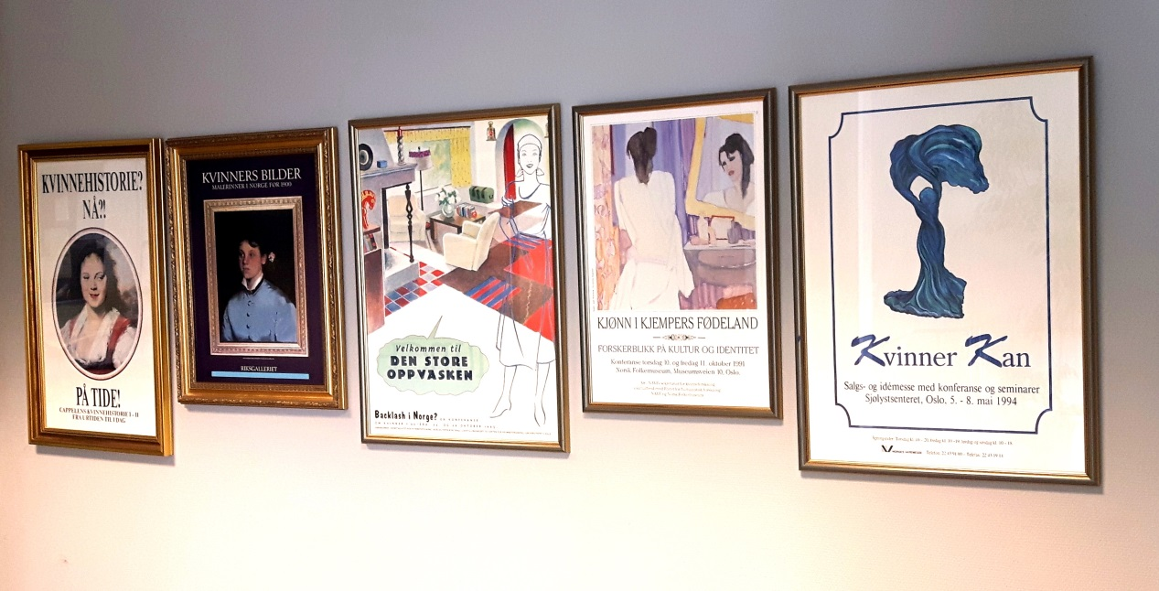
LIFE AROUND THE STUDIES

The STK Student Committee
The student committee at the Centre for Gender Research (STK) consists of students at the Centre and is elected in the beginning of every academic year. Our task is to attend to students' academic and social interests, through events and meetings for students.
Who are we?
Since the autumn semester 2016, the Student committee has consisted of:
- Anja Lovise Skogen: - Leder og økonomiansvarlig
- Miriam Abel Hansen: Nestleder
- Mirjam Johannessen: (medlem TKS programråd)
- Helene Ruud: Styremedlem
- Charlie Bilstad: (Representant STK styre)
- Vincent Valentin Hjelland: (Vararepresentant for STK styre)

What do we do?
Throughout the semester we organize both social and academic events.
Also, we represent STK students in contact with the Centre management and others, not only through the committee’s work but also through our two student representatives to the STK board. It is mostly the members themselves who decide what to do, but the student committee also has regulations that have been approved and accepted by the students.
One of the student committee’s responsibilities is the master students’ reading room on the 2nd floor of the NEMKO building. This means that we organize the allocation of permanent reading places and lockers.
We post info about our events regularly on the STK webpage, but also on the Facebook group for STK students. We also publish current news and other info we believe could be interesting for the students.
Contact us!
You are most welcome to contact us if you have something you want to discuss. This can be anything from lighting in the reading room to courses and social events. Do you know anything STK students should know about? Send an e-mail to: studentutvalget@stk.uio.no
More information…
About being a student at the University of Oslo: http://www.uio.no/english/studies/
Who do I contact? http://www.uio.no/english/studies/contact/
Appendix I
Supervision Agreement for Faculty of Humanities
Centre for Gender Research, P.O. Box 1040 Blindern, NO-0315 Oslo. Tel. No. +47 22858930 E-mail address: postmottak@stk.uio.no Website: www.stk.uio.no
Student name: ……………………………………………………….……………….
Study programme and study option: ……………………….……………………….
Supervisor/ Principal supervisor: ………………………………………………………
Co-supervisor (if any): ………………………………………………………………
Proposed thesis title (or working title of the thesis): ……………………………………………………………………………………………………………………………………………………………………………………………………
Period of agreement: …………………………………………………………………………
Percentage distribution of supervision between Chief Supervisor and Co-supervisor:…………………………………………………………………………………………………………………………………………………………………………………………………………………………………………………………………………………………….
Intended date of thesis submission: …………………………………………………………..
Course code for Master thesis: ……….

RIGHTS AND OBLIGATIONS IN THE SUPERVISORY RELATIONSHIP
- The supervisor and the student should, at the outset of the supervisory relationship, discuss and agree on the format of supervision, the expected progress and the intended date of thesis submission.
- The supervisor and the student should, at the outset of the supervisory relationship, discuss and agree on a written plan that includes important milestones for the thesis.
- The supervisor and the student should be familiar with the ethical considerations that apply to the collection, storage and publication of personal data, including the fact that some projects must be reported to the Norwegian Social Science Data Service (NSD). The National Committee for Research Ethics in the Social Sciences and the Humanities defines the norms for thesis/dissertation work. Please review the following webpages: http://www.nsd.uib.no/nsd/english/pvo.html,http://www.nsd.uib.no/personvern/meldeskjema?eng, http://www.uio.no/for-ansatte/arbeidsstotte/personvern/former-for-behandlinger/behandling-av-personopplysninger-i- forskning.html.
- If relevant, the supervisor must ensure that the student complies with the duty to report to NSD. Please observe that data collection cannot start before permission is granted from NSD. The director of the Centre should be registered as “Daglig ansvarlig” in the form.
- The supervisor and the student should observe the regulations and instructions governing the supervision of master theses.
- In case a co-supervisor is considered necessary, approval should be sought and granted by the relevant department before the agreement is made. Approval is granted only under exceptional circumstances.
Student
- The student should be well prepared for meetings with supervisor.
- The student should write a short report after each supervision meeting. This report should include a summary of the supervision, and the date for and the tasks the student should complete for the next supervision. A copy should be sent to the head of the study programmes, Elisabet Rogg and student advisor Helle P. Granum.
- The student should give sufficient notice to the supervisor if he/she is not able to attend a scheduled meeting.
- When there are serious problems in supervision, the student should immediately bring this to the attention of the office manager at STK/Centre for Gender Research.
- In case the thesis cannot be completed within the period of the agreement, the student must apply for an extension of the supervision agreement.
Supervisor
- The supervisor should be familiar with and follow the ethical guidelines for supervisors at the University of Oslo. He/she should also ensure that students are aware of the guidelines.
- The supervisor should ensure that the first meeting with the student takes place shortly after having been assigned, in which the supervisor should discuss with and inform the student about how the supervision is to be organized.
- The supervisor should offer the student up to 15 hours of supervision for a 60-credit master thesis (up to 7.5 hours for a 30- credit master thesis), distributed evenly throughout the supervision period.
- The supervisor should be well prepared for the meetings with the student.
- The supervisor should discuss with the student as well as evaluate the plan, the methodology and execution of the proposed research. He/she should assist the student in planning the research with a view to completing it within the normal period of study.
- If the project will be based on data from individuals, Norwegian Social Science Data Service (NSD) must be notified at least 30 days prior to starting the collection of data. The National Committee for Research Ethics in the Social Sciences and the Humanities defines the norms for thesis/dissertation work. Please review the following webpages: http://www.nsd.uib.no/nsd/english/pvo.html, http://www.nsd.uib.no/personvern/meldeskjema?eng, http://www.uio.no/for- ansatte/arbeidsstotte/personvern/former-for-behandlinger/behandling-av-personopplysninger-i-forskning.html. If relevant, the supervisor must ensure that the student complies with the duty to report to NSD. Please observe that data collection cannot start before permission is granted from NSD.
- The supervisor is expected to read and give detailed comments on the draft of the thesis chapters at least once, but the supervisor will exercise his/her own judgment in how far it is necessary to give detailed comments on revised chapters and the completed thesis.
- The supervisor may, if appropriate, carry out part of the supervision in small research seminars.
- The supervisor should, through the meetings with the student, monitor the progress of the student’s work and evaluate the progress in relation to the planned schedule.
- The supervisor should give sufficient notice to the student if he/she needs to re-schedule a meeting.

Modification or Termination of Supervision Agreement
Changes can be made to the supervision agreement (for example, changing the research topic) when both the student and the supervisor agree. When the supervisor is to be absent for an extended period of time in the course of the supervisory relationship, the class coordinator should, in consultation with the student, determine how the supervision can be organized during this period. In case the department considers that the student is not acting according to the supervision agreement, he/she should be notified in writing.

If the supervisory relationship is not deemed by the student or the supervisor to be working satisfactorily, for academic or other reasons, either side may request to be released from the supervisory relationship. A new supervisor should then be arranged.
The student may be considered as not acting according to the supervision agreement in cases when
(a) the student fails to submit the master thesis within the semester which the thesis is due for submission (i.e. the fourth semester of a full-time master programme), and has not been given approval for an extension and a new submission date (subject to Section 7.1.6 and 7.2.1 of the Regulations Governing Studies and Examinations at the University of Oslo and the Guidelines for Deferred Commencement of Studies, Leave and Part-time Studies for Programme Students).
(b) the student has not contacted the supervisor for two semesters. In such a case, the research can be taken up by other students.
(c) the allotted hours of supervision have been used up, and the student has no approved plan for submission of thesis.
The supervision agreement ends when the student:
(a) submits the master thesis,
(b) is considered as not acting according to the agreement and has been notified of it in writing, and has not received approval for a new plan for submission,
(c) forfeits or gives up the right to his/her place in the master programme concerned.

SIGNATURES
Student: ………………………………………………………………………….
Supervisor: ………………………………………………………………………
Head of studies: ……………………………………………………………..
Appendix II:
Schedule and work plan
The schedule and the work plan are to be agreed upon jointly by the supervisor and student. Departures from the agreed plan must be communicated to the Centre. The supervision resources consist of max. 15 hours of face-to-face supervision for a 60-credit master thesis (45 hours are reserved for preparation).

 | Number of meetings | Sub-goals
1st semester
2nd semester
3rd semester
4th semester

Appendix III:
Application for supervisor for the Master’s thesis in Gender Studies

Semester and year: ……………………………

Name of student: ...............................................................................
Address: ................................................................................................
Postal code/place: .................................................................................
Field of interest for the thesis/working title: ……………........................................................................................
............................................................................................................
............................................................................................................
............................................................................................................

Do you want a specific person as supervisor?

Name: ...................................................................................................

Have you been in touch with that person? (please tick as applicable)
Yes
No

For STK (do not write here)
Assigned supervisor: ............................................................................

Any comments: ……………………………………………………………………………………………………………………………………………………………………………………………………
STK contact information

Head of Studies
Helene Aarseth: helene.aarseth@stk.uio.no

Student Advisor:
Helle Pedersen Granum: hellepg@stk.uio.no

The STK administration:
postmottak@stk.uio.no

STK homepage
(English):
http://www.stk.uio.no/english/

Phone (general office):
+47 22858930

STK visiting address:
The Nemko building,
4th floor, Gaustadalléen 30 D, 0315 Oslo, Norway
(map)

