Name: | Date of birth:
Unit: | P.O. Box of unit:
Works at: One computer screen Two computer screens Computer work in reception

Work place review
Managers must ensure that the workplace is properly arranged and lighting is good before the eye sight test.
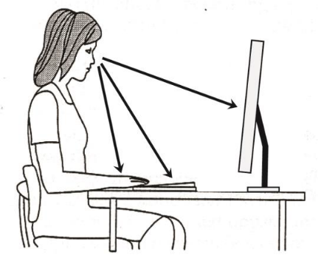
- Recommended distance to monitor is 60-80 cm. Enter the distances measured on the arrows in the figure on the right.
- Place the keyboard slightly in from the edge of the desk. There should be room for the employee to rest forearms on the table.
- The line of sight to the reading area of the screen should be 35-45 degrees below the horizontal.
- It should be possible to adjust both the height and the angle of the screen
Eye tests
Opticians will perform eye tests according to the Regulation on working at computer monitors, with guidelines.
Purchase and reimbursement
- Ask the optician to fill out and sign the "Optician's Report" and assess the need for computer glasses. If single strength lenses are not appropriate, the optician must justify other solutions for the glasses.
- The employee pays upfront and requests reimbursement via the self-service portal — see the guidance. Under expense category and type, select “screen/computer glasses” (Norwegian: «skjerm-/databrille»)
- Computer glasses paid for by the University include single or multifocal computer glasses with anti-reflective treated glass/plastic lenses, eye test and frames. Prices of over NOK 1000 for the frames are not refundable.

Date: Choose date Manager’s signature: __________________________________

Rapport from optician:
 | OD |  |  |  |  |  | OS
 | sph |  | cyl | akse | prism | visus | sph | cyl | akse |  | prism |  | visus
Avst.korreksjon
Lesekorreksjon
Datakorreksjon
Behov for databrille: |  |  |  |  |  |  |  |  |  | Nei |  | Ja
Behov for vernebrille med styrke: |  |  |  |  |  |  |  |  |  | Nei |  | Ja
Type korreksjon som anbefales: |  | Enstyrkedata |  |  |  |  |  |  |  | Nei |  | Ja
 |  | Dataprogressive |  |  |  |  |  |  |  | Nei |  | Ja
 |  | Skranke- og rom-progressive |  |  |  |  |  |  |  | Nei |  | Ja

Begrunnet behov:

Sted: Dato:

Optikers stempel og underskrift:

