Apartment for Rent, Blindern/Ullevål
Hasselbakken is located in a popular residential area between the University of Oslo Blindern campus, Ullevål Hospital and Vestre Aker Church. Secluded and quiet just a 5 minute walk to John Colletts Plass/Blindern with short distance to most of the city's amenities. The apartment is in lower floor of a villa with a sizable garden in a wooded area located on top of a hill at the end of a scenic deadend street.
This 2-room, partially furnished apartment is 55m² with separate entrance, living room, bedroom, bathroom, and kitchen with stove, fridge/freezer, dishwasher, washing machine and dryer. Floor heating cables in the living room, kitchen, bedroom and bathroom. In addition, a separate slate covered 20m²terrace adjacent to the apartment with a small flower bed. The apartment is equipped with fiber cable for TV and broadband to which the tenant can subscribe.
Rent per month kr. 16,000 including separate security and fire alarm, electricity, water and heating. Deposit kr. 48,000.

Hasselbakken 11
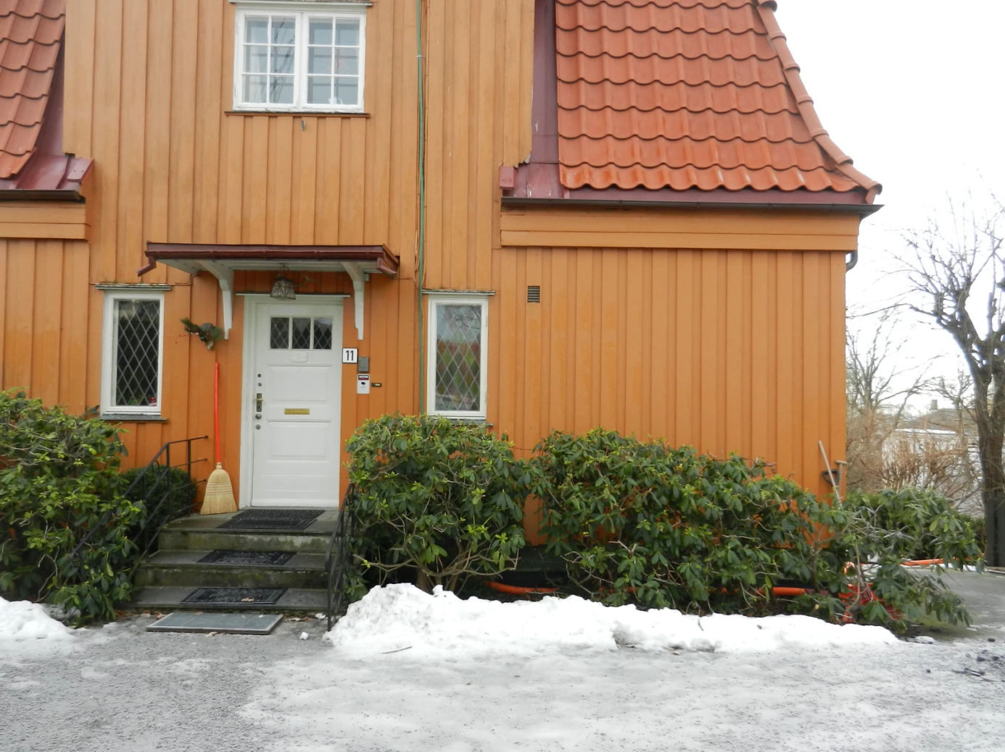

Living Room (does not include sofa and armchairs) 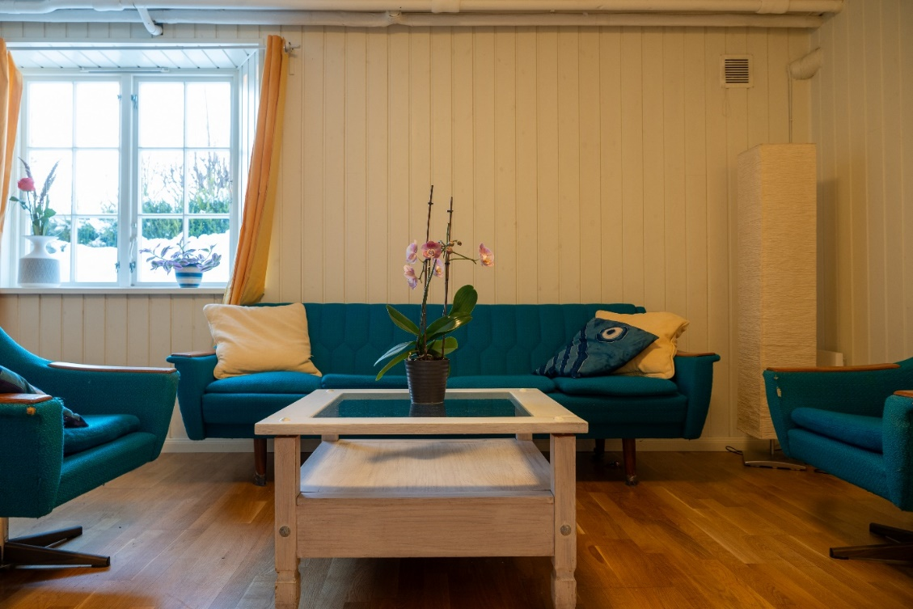

Bedroom (includes bed and built in closet)
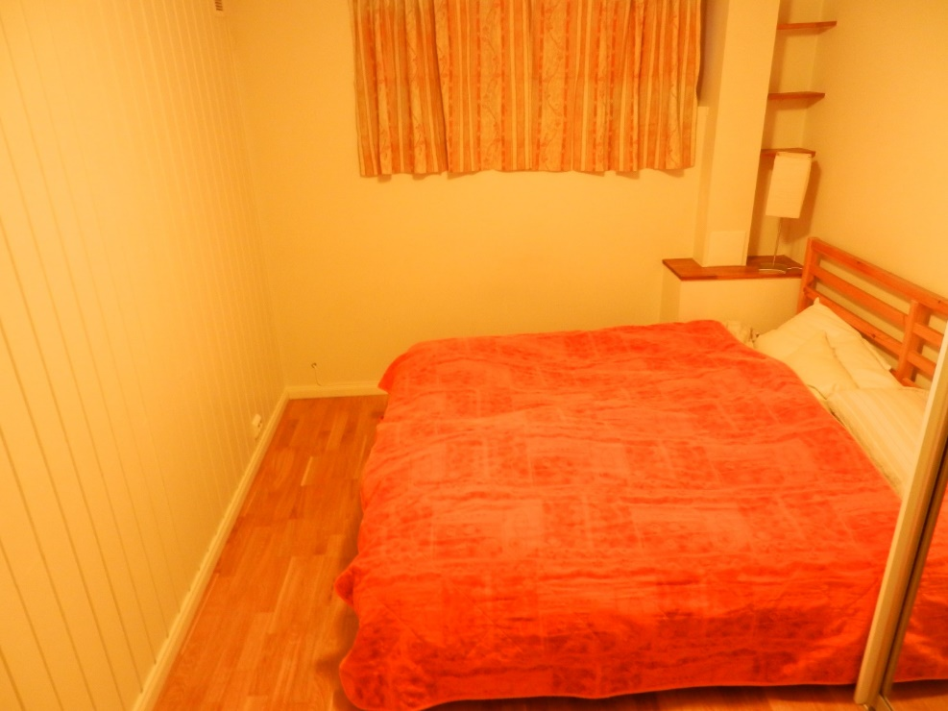

Kitchen
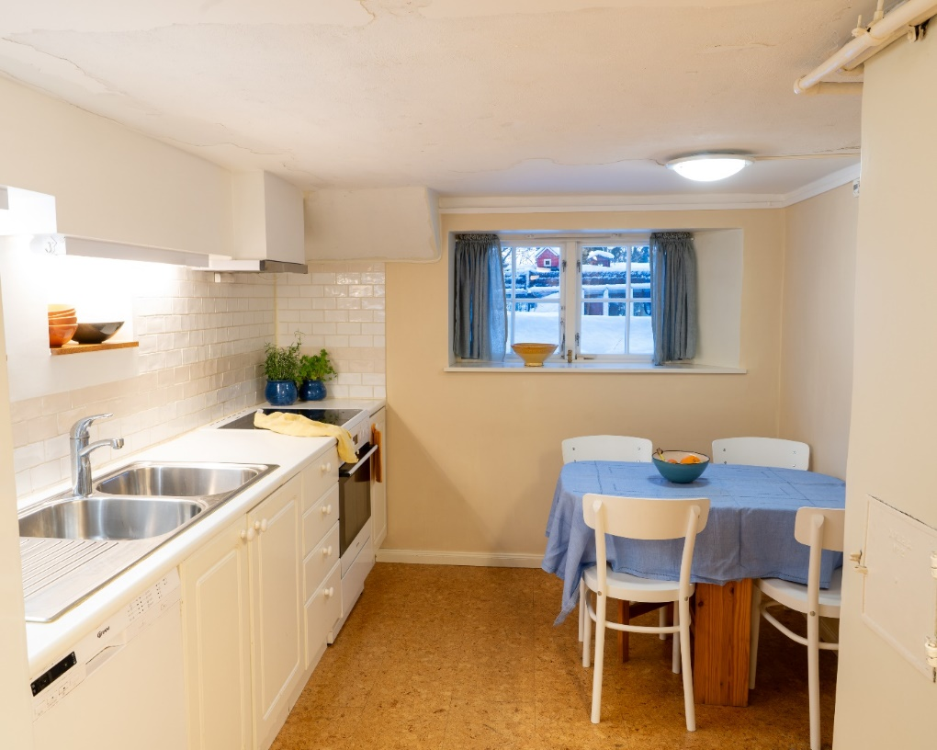

Kitchen
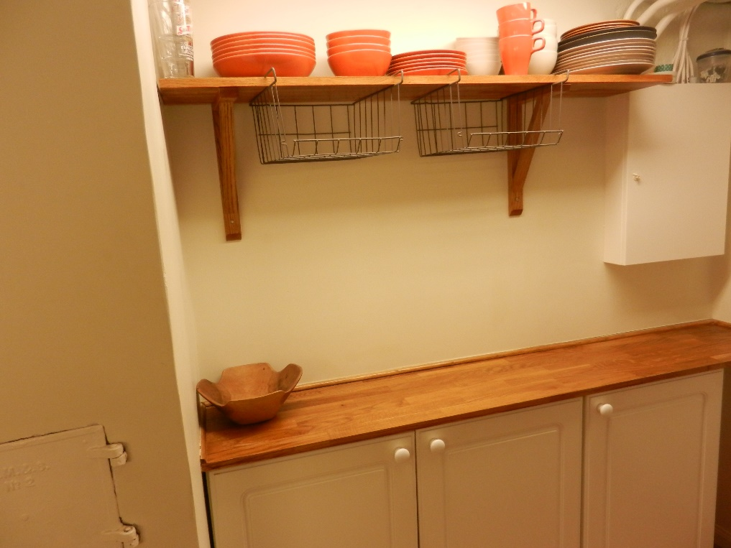

Bathroom
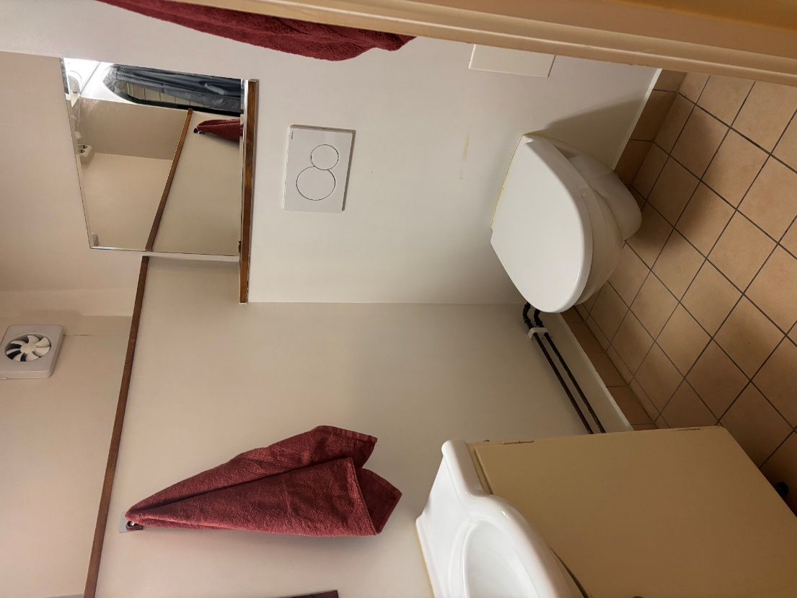

Bathroom Shower
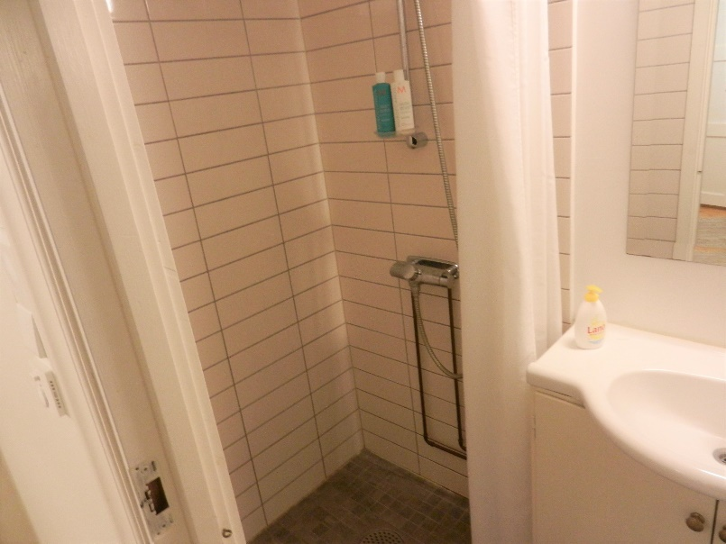

Terrace
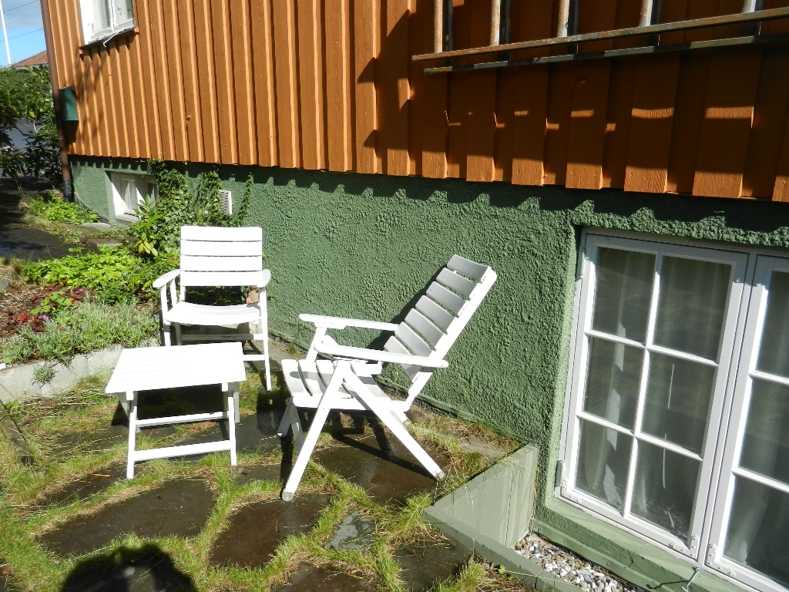

Floorplan
