Areas:
Primary: 72 m2
Brutto: 80 m2
Parking: private parking indoors
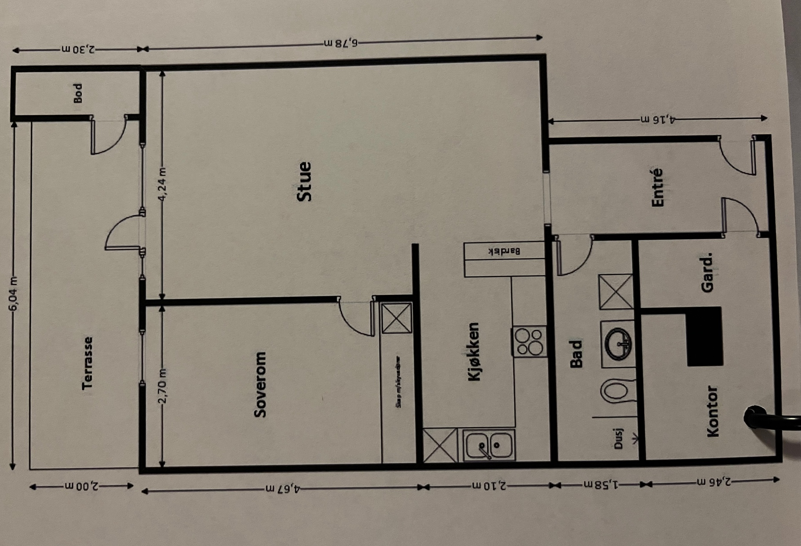
Summary
The apartment consists of an entrance, small bedroom/office, bathroom, large bedroom and living room with kitchen. The apartment is fully furnished with kitchen utensils and pillows/duvet.

Entrance
The spacious entrance hall gives a nice and representative first impression of the home with tiled floor, gray painted walls, underfloor heating and spotlights. The entrance has space for storage furniture. Next to the cave entrance door with code lock (key free) and the installed door calling.

Living room
The living room is spacious and feels like an inviting room with dark laminate, walls painted in a contemporary gray tone and downlights along the outer edge of the ceiling. Large window surfaces along the end wall provide good light conditions (sun in the afternoon until sunset) and there is access to a large, south-west facing terrace with a lovely view over nature, Oslo and the fjord. The living room includes a sofa group, dining table with 6 chairs and 2 pieces of furniture for minor storage. Currently there is also an office desk with chair.

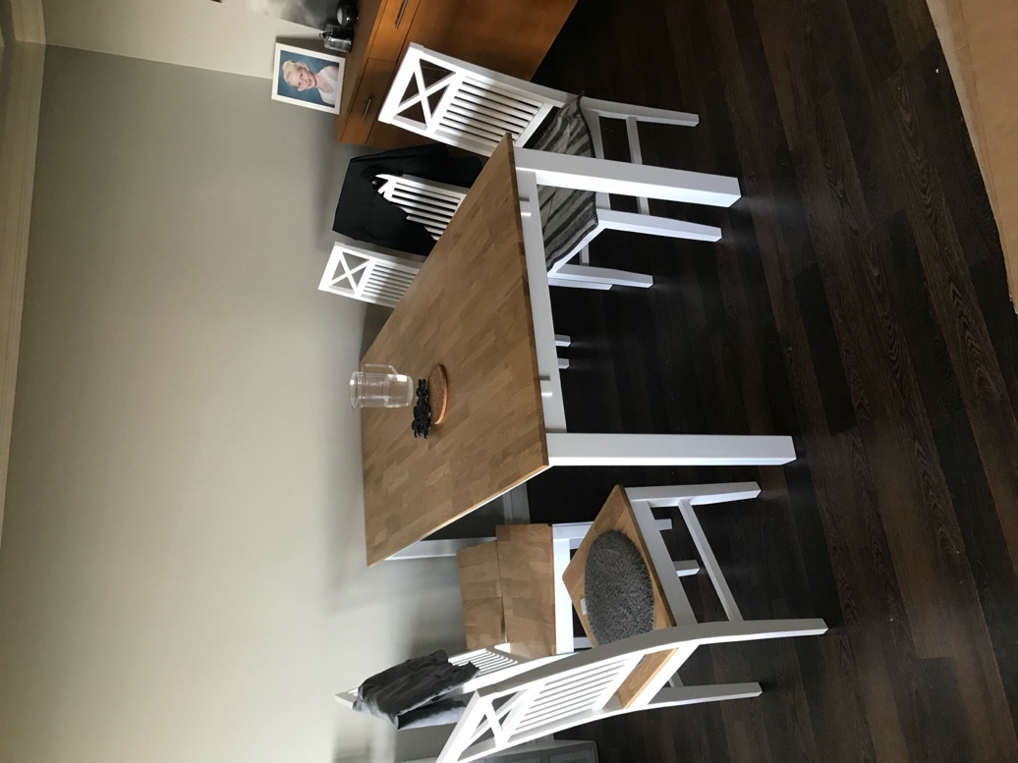
The dining area
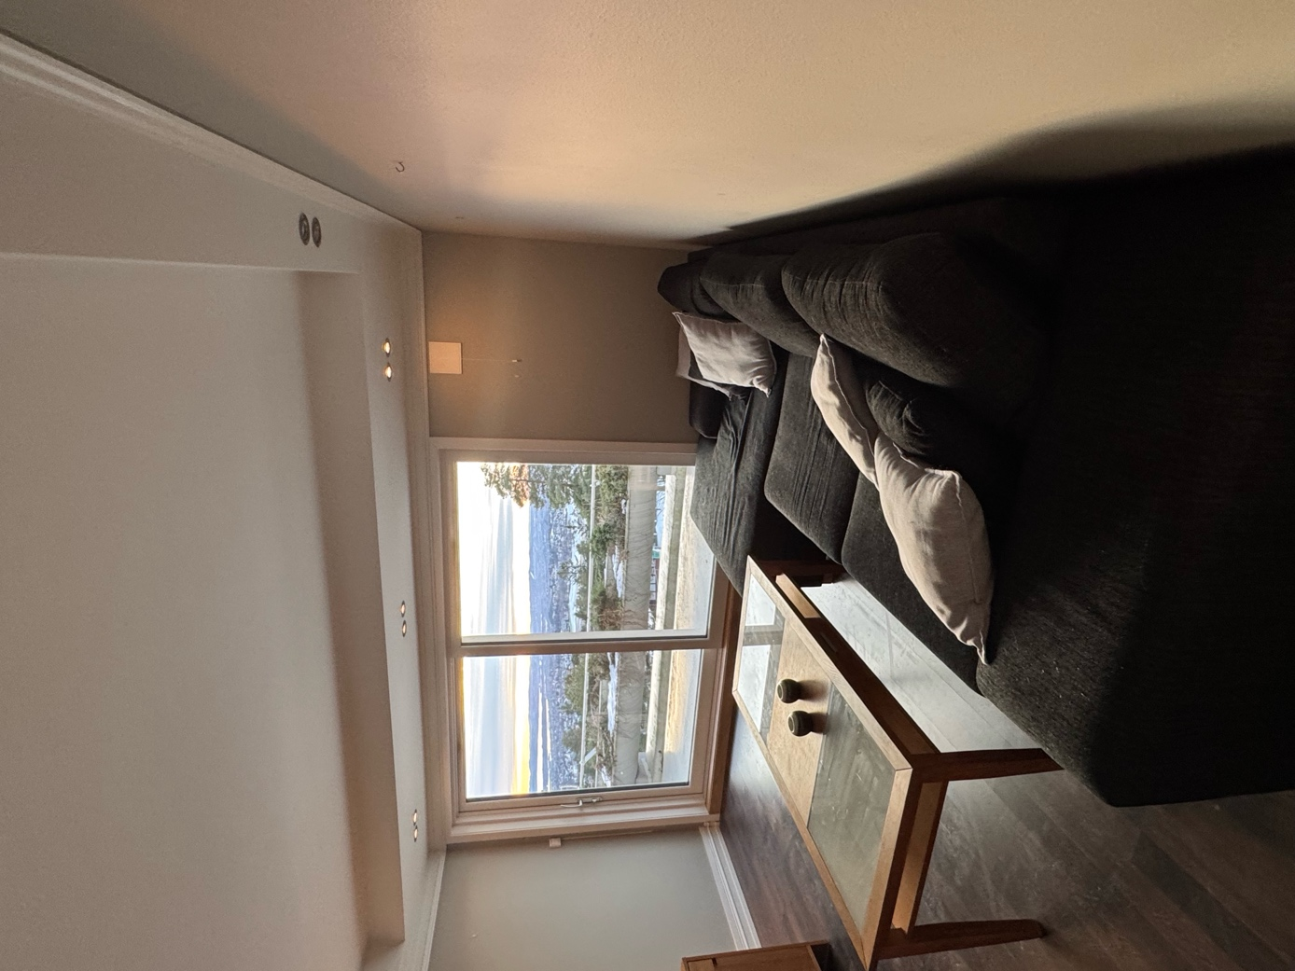
The sofa and window front.

Kitchen
The kitchen is partially open to the living room's dining area and with a great bar solution as a natural separation between the rooms. The kitchen consists of a ceiling-high interior and sink. The kitchen has a tiled floor, a wall with stylish, black tiles and a nice dining area by the bar solution. Above the bench there are white tiles and good bench lighting, and above the cooking zone there is a ventilator with a central exhaust. The kitchen is also equipped with integrated white goods in the form of a ceramic hob, oven, microwave, dishwasher and fridge/freezer. The kitchen is fully equipped with cooking utensils, plates, etc.
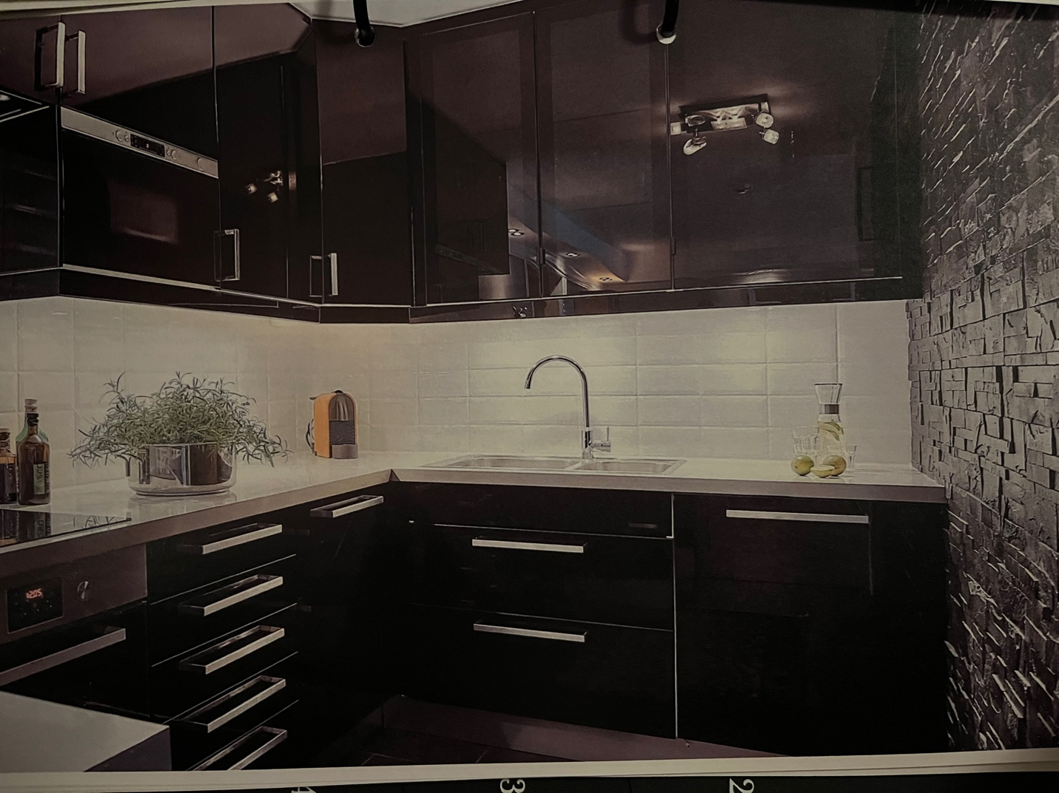

Bathroom with toilet and washing machine
The bathroom was upgraded with dark floor tiles and decorative tiles in certain places, underfloor heating and mechanical exhaust. The interior has dark, smooth drawer fronts, a full-covering washbasin or a large cupboard with overhead lighting. The bathroom also has a free-standing toilet, shower with glass walls and a washing machine.
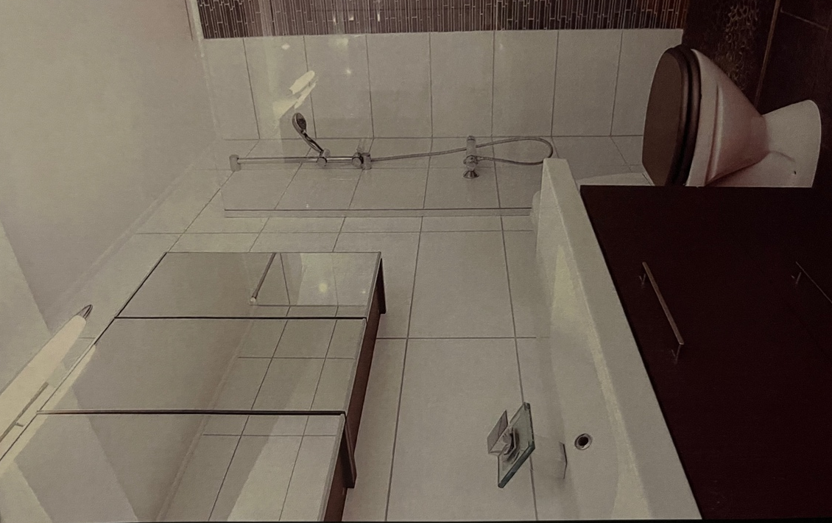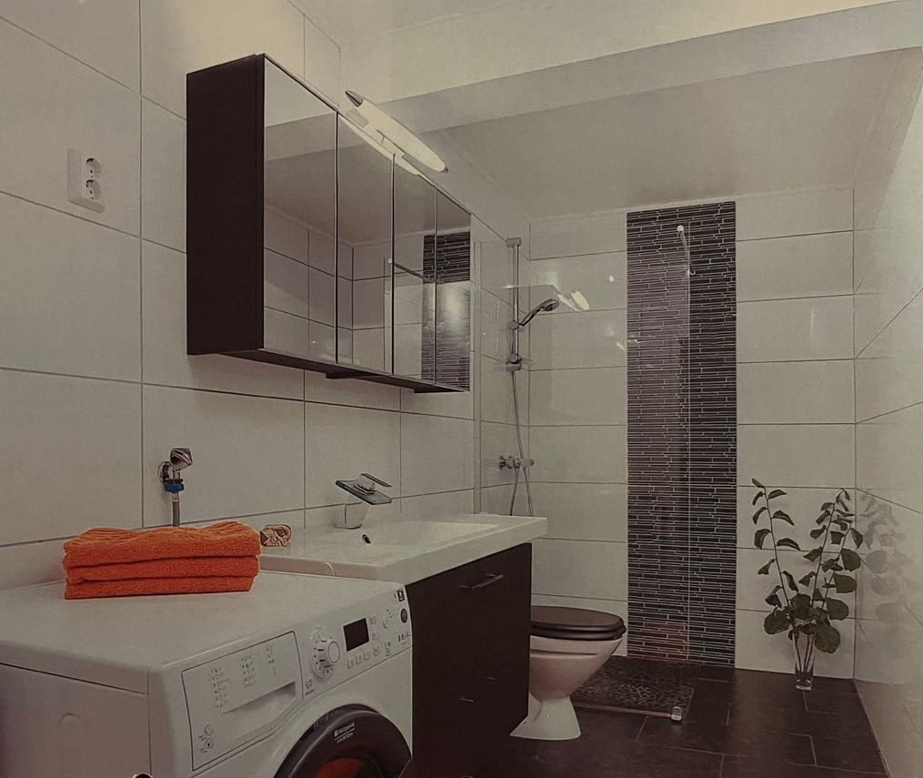

Large bedroom with storage
The bedroom has laminate on the floor, downlights in boxes along the outer edge of the ceiling, subdued color on the walls and a wallpapered background wall. The room has a double bed and two bedside tables, and one end of the room has a large sliding wooden door wardrobe with black fronts.
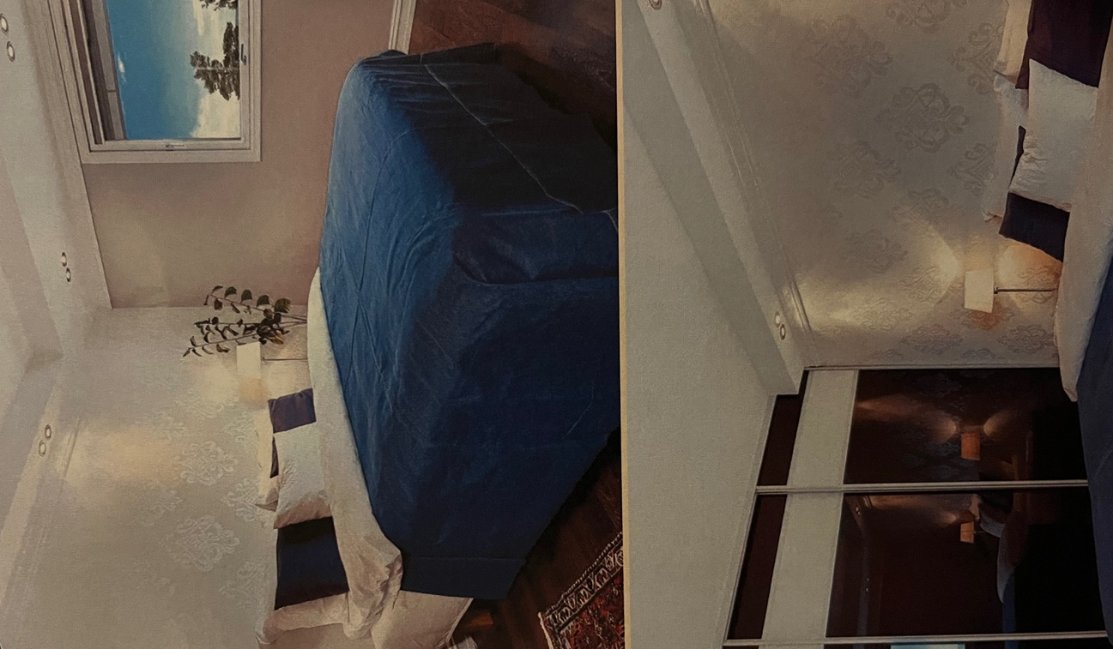

Small bedroom/office
This small bedroom has a bed and some furniture for storage. There is space to move the office table and chair here.
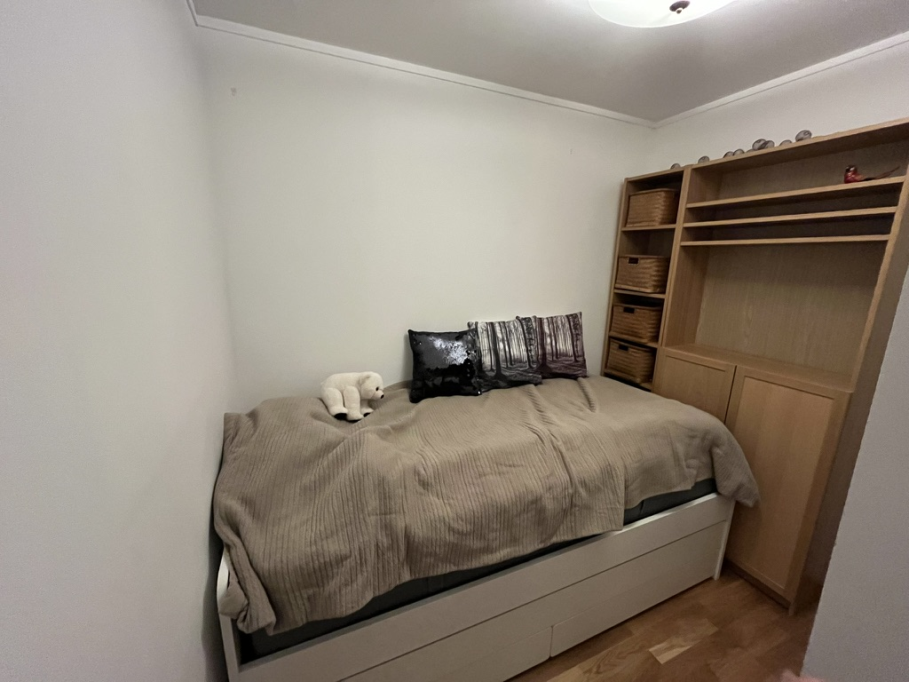

Parking
The apartment comes with one parking spot in a closed area under the building. There is additional parking for guests and street parking.

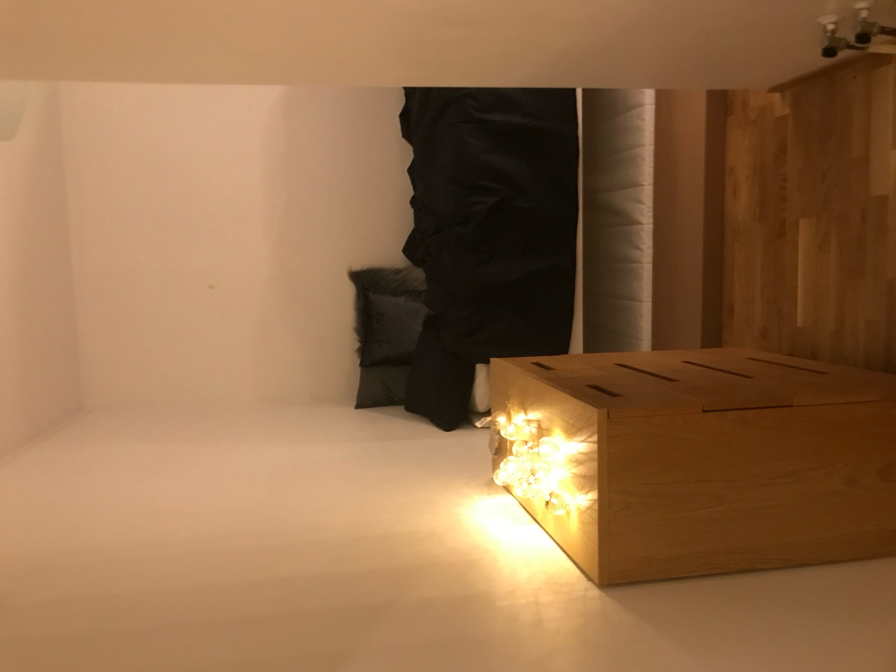
Small bedroom without window.

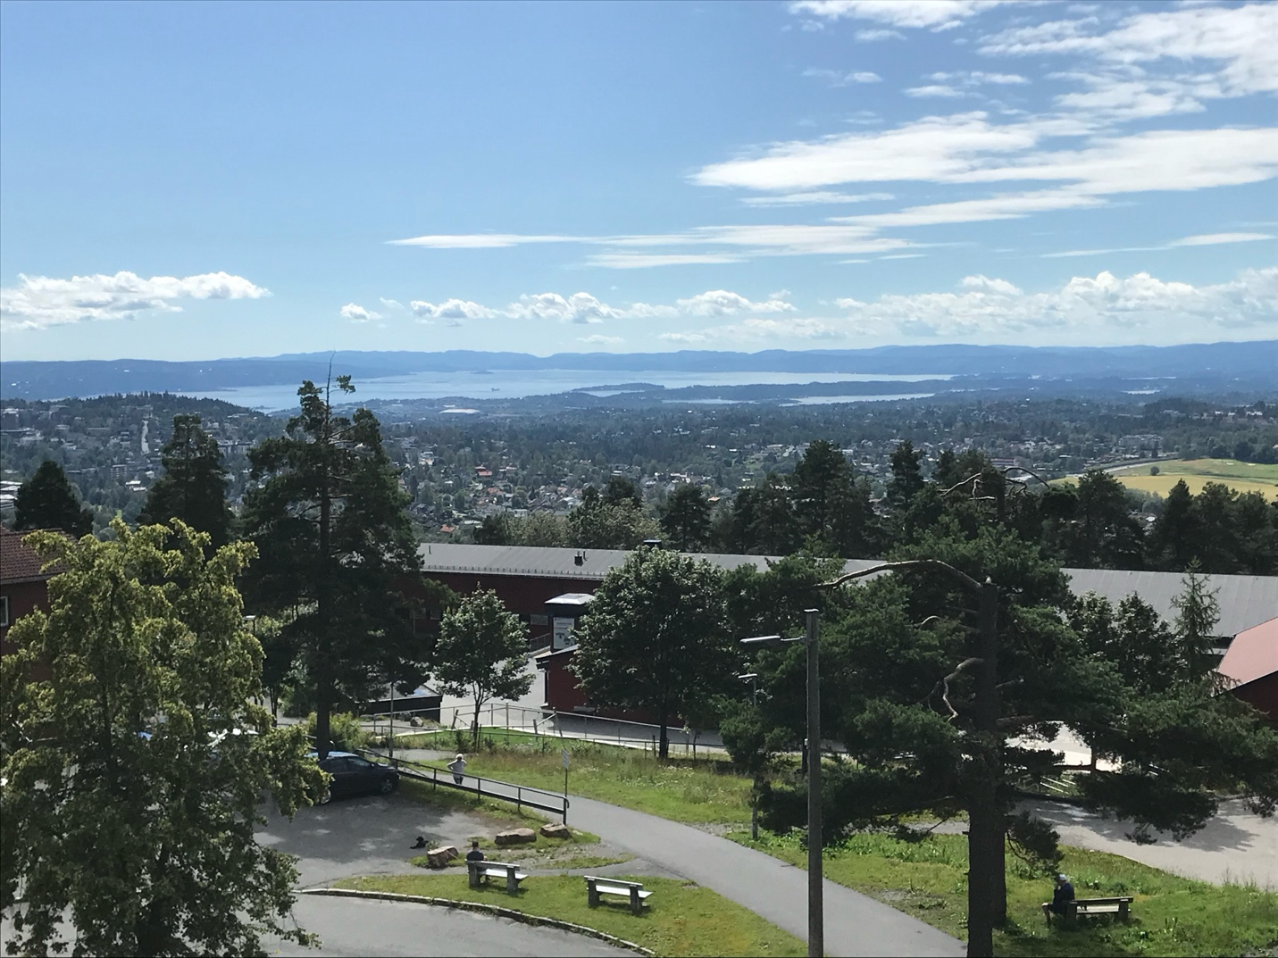
View from balcony

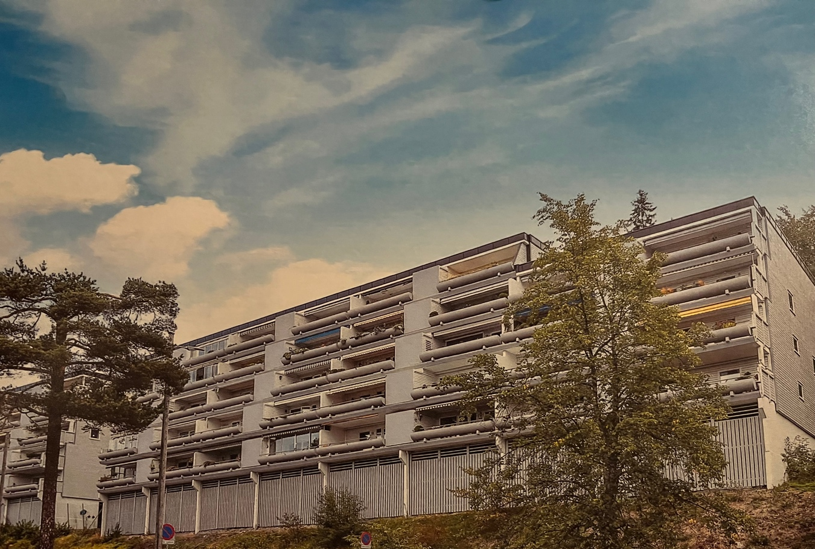
The building. The apartment is on the second floor (building entrance on floor down).

