Furnished apartment for rent in Tøyen, February–August 2026 (6 months, may be available from January if necessary)
Ideal for weekly commuters, professionals, or academics seeking a modern, quiet, and centrally located apartment in Oslo for a limited period.

About the apartment
- Bright, spacious, and stylish apartment with 2.7 m high ceilings
- Fully furnished: living room set, dining table/chairs, and complete bedroom furniture
- Newly renovated in 2024 with a modern kitchen, upgraded surfaces, and high-quality appliances
- Washer/dryer machine included
- Prime location in Tøyen: 5 minutes to the metro, 15 minutes walk to Oslo Central Station
- All windows face the inner courtyard, creating a private, quiet atmosphere (good sleep guaranteed)
- Pets allowed in the building
- Access to a shared rooftop terrace and a green inner courtyard with seating and barbecue facilities

A perfect choice if you want to live comfortably and centrally in Oslo.

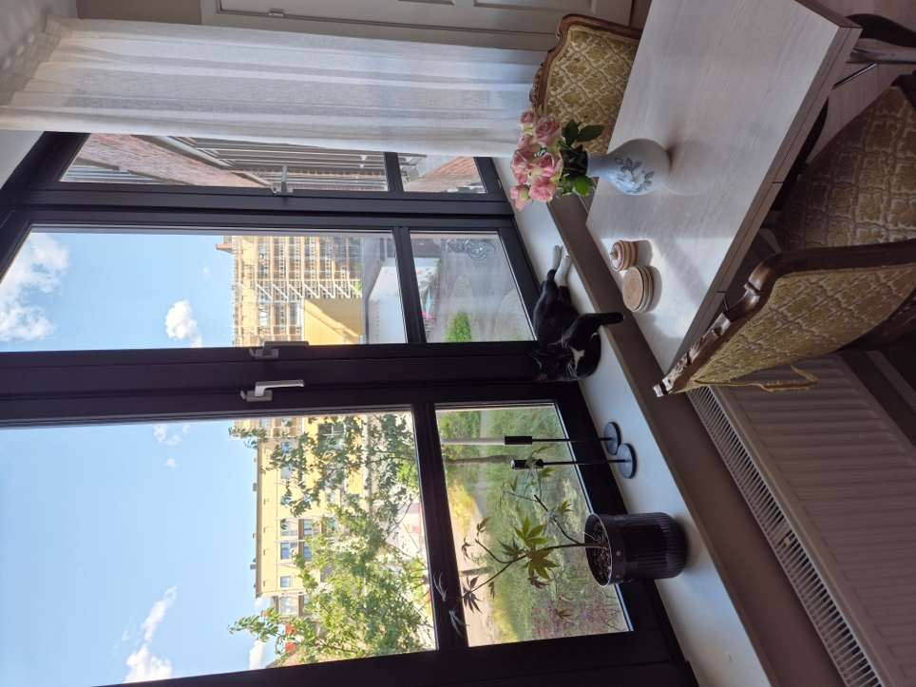
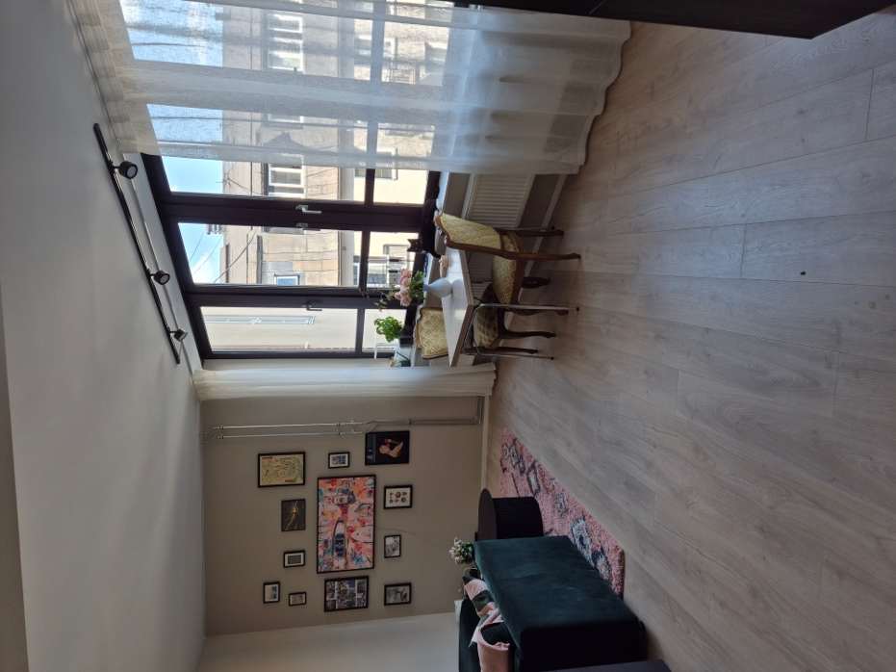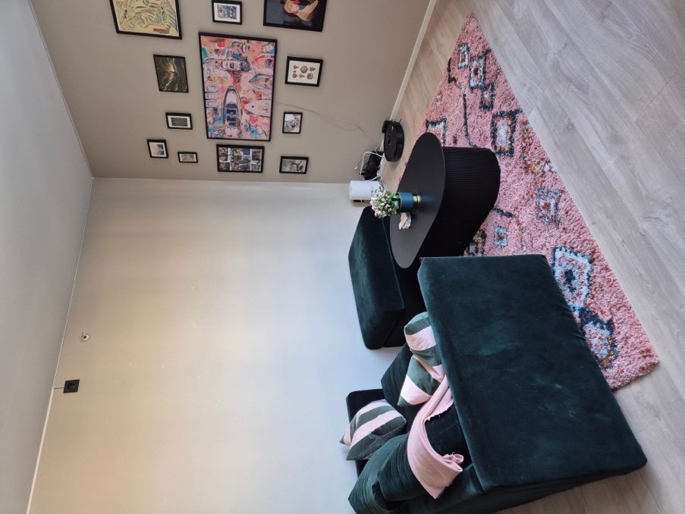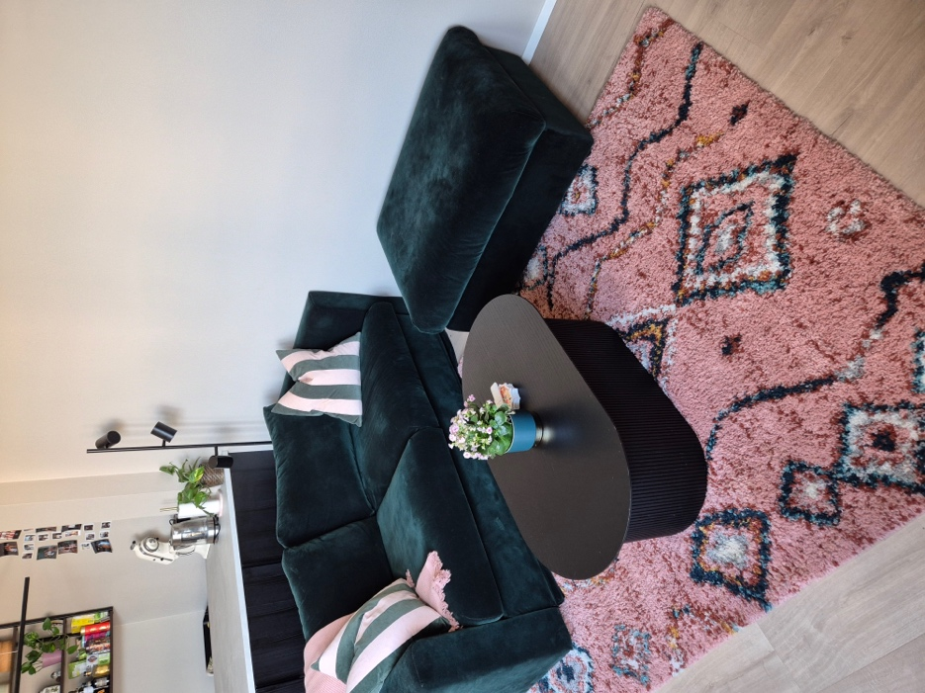

Living room/dining area
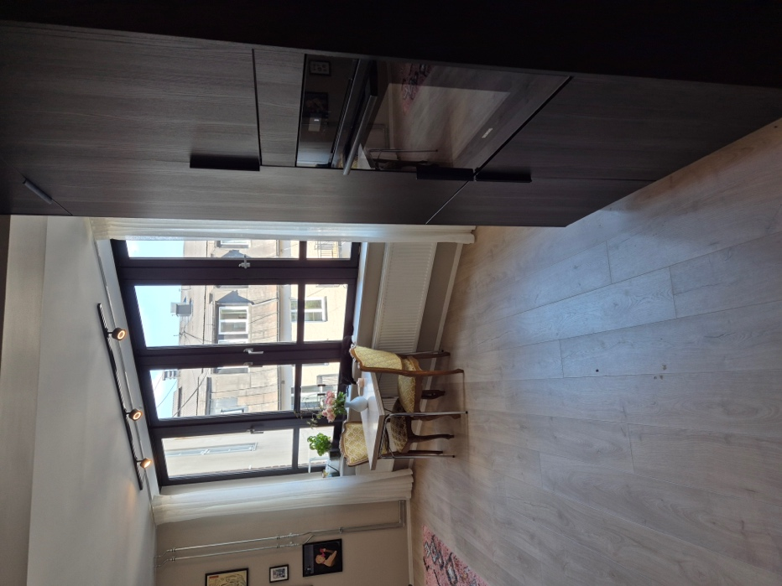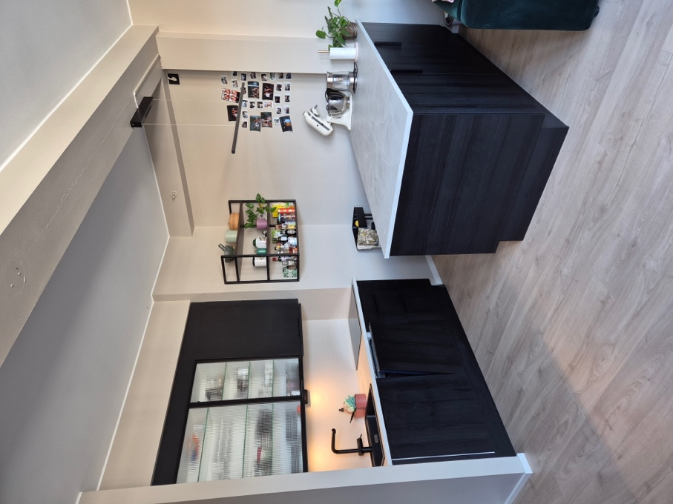

Kitchen
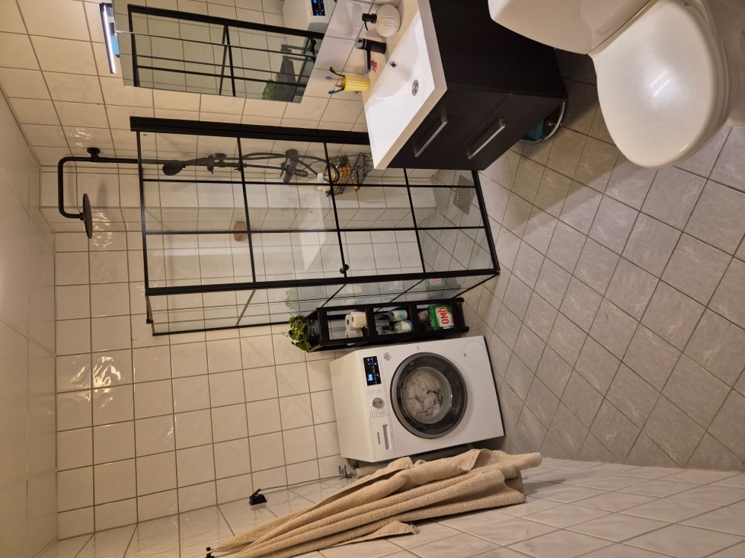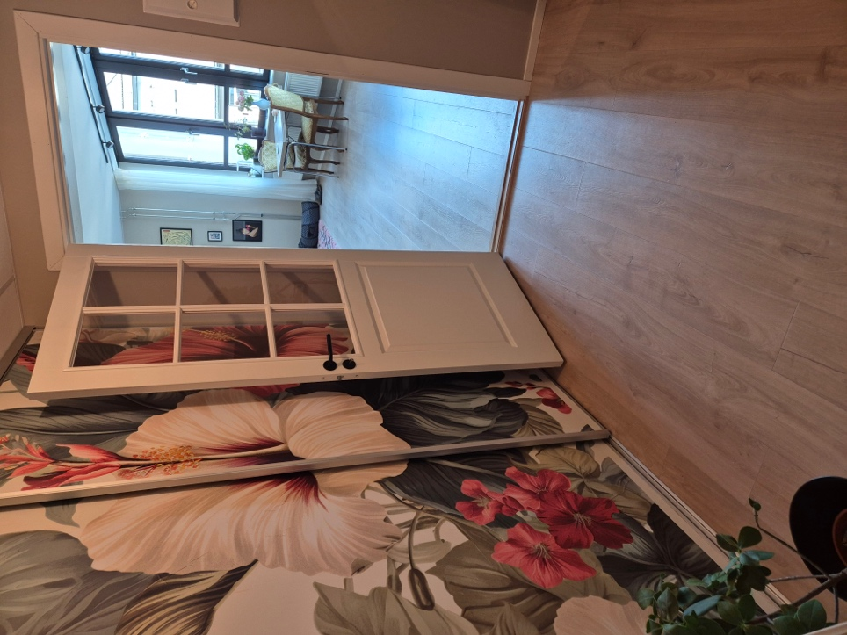

Bathroom and hallway

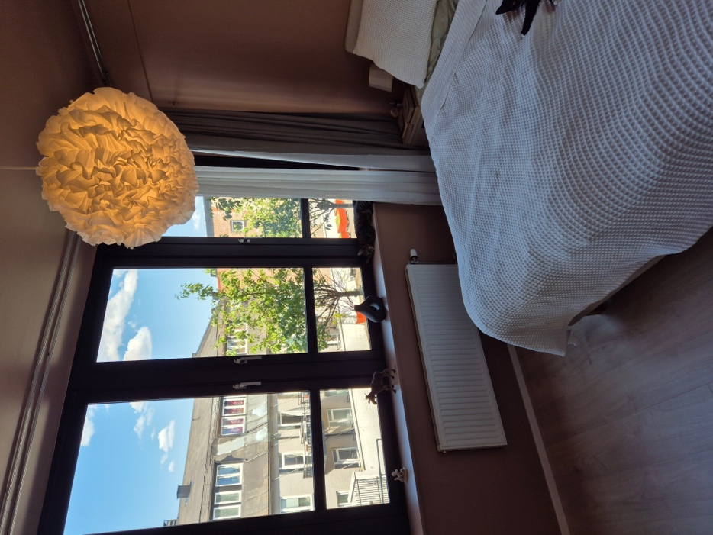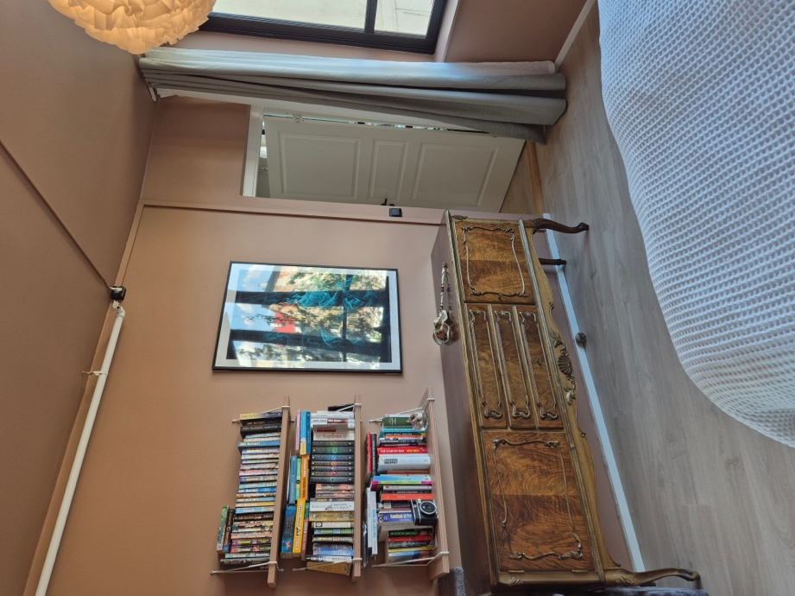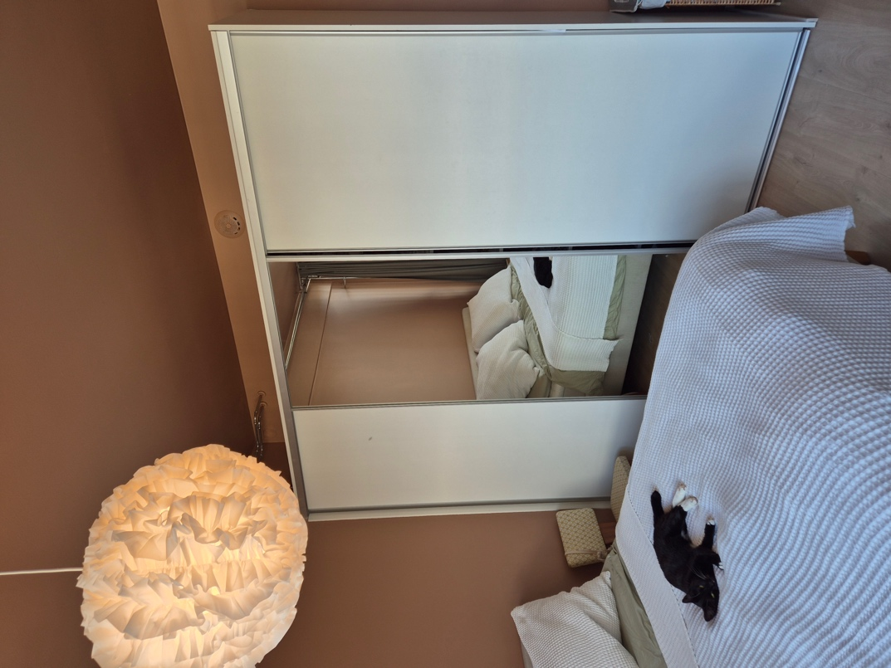

Bedroom
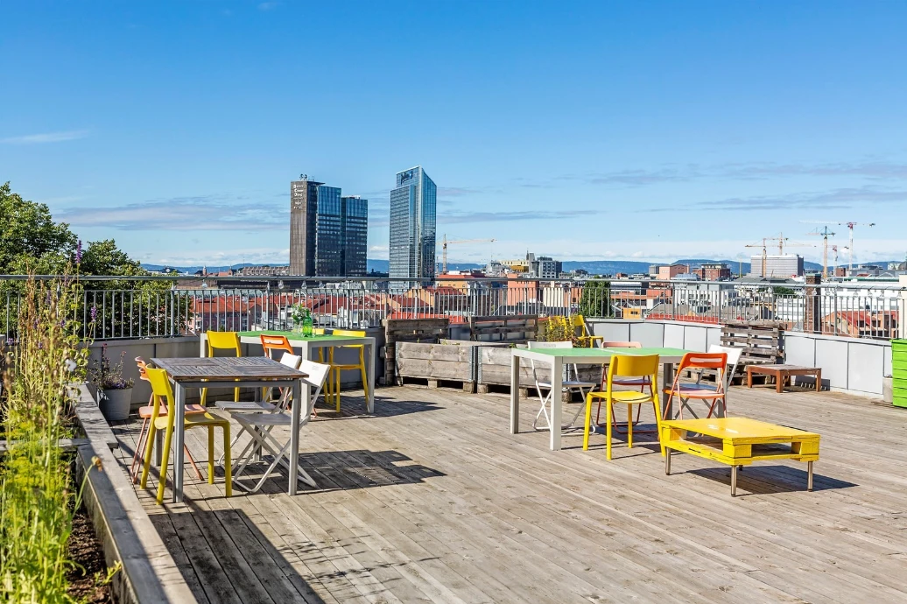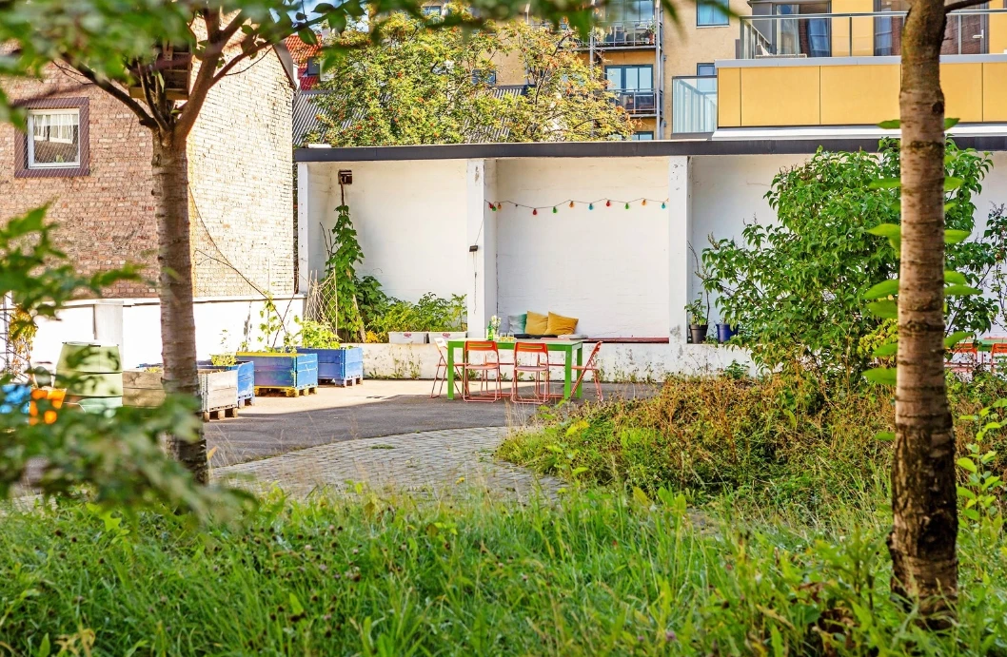

Shared roof terrace and inner courtyard

