Title of the conference

Practical information

How to get to Oslo city center:
In order to get from the airport to Oslo, you should use the Airport Express Train:
https://flytoget.no/en/#
It leaves from inside the Oslo Airport terminal building. The train departs every 10 or 20 minutes, depending on the time of day. In order to obtain a ticket, use the service booths or the grey and orange automats.
The charge is 190 Norwegian Kroner (NOK). All major credit cards are accepted.
The stop nearest by your hotel is Nationaltheatret – the National Theatre. This is the first stop after Oslo Central Station. Please keep your ticket for reimbursement.

How to get to get from Nationaltheateret station to the conference venue:
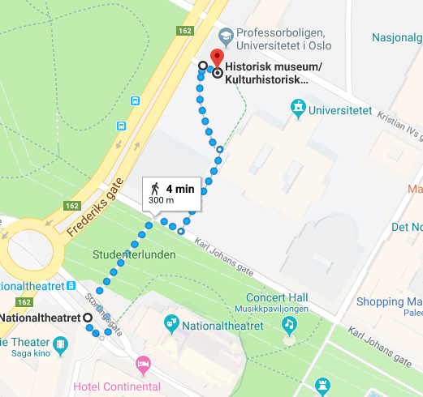
The conference will take place in a building called Professorboligen. The building is located in the garden of the Law faculty.
Here is a map showing how to get to Professorboligen:

How to get from the conference venue to your hotel:
Your hotel is Clarion Collection Hotel Savoy
The address of the hotel is:
Clarion Collection Hotel Savoy
Universitetsgata 11
0164 Oslo
This is a map showing how to get to your hotel:
