UNIVERSITETET
I OSLO
 Institutt for litteratur, områdestudier og europeiske språk

WRITTEN EXAMINATION
AUTUMN 2015
5 pages

ENG4163 – Global English
4 hours Monday 14 December 2015
Candidates are allowed to use ONE English–English dictionary.
All questions must be answered in English.
Answers must be written on copy-sheets.

Answer ONE question from Part I and ONE question from Part II. Pass marks are required on both parts.

Part I
(60 %)
EITHER

- Give an account of the use of the auxiliary shall in the main national varieties of English, drawing on relevant texts from the reading list for this course. In your account you should comment on the attached result of a Chart search on shall in the Corpus of Contemporary American English. The attachment also includes the beginning of a random sample of 100 hits from the corpus as a whole. You should explain what a random sample is, and discuss the usefulness of random samples in linguistic research. You should also suggest other corpora which might be examined in order to test the use of shall (even in the other main national varieties). (Text provided, no. 1)

OR

- Give an account of the various mandative constructions which occur in English. Then discuss what light the attached results from Johansson (1979), ‘American and British English grammar: An elicitation experiment’, may shed on the expression of mandative meanings in American vs. British English. In your answer you should take care to explain the way in which results from the elicitation test are presented in the article (see the attachment). You should also suggest corpus searches (search strings and corpora) which could be carried out to test the expression of mandative meanings further (even in the other main national varieties). (Text provided, no. 2)

Part II
(40 %)
EITHER

- Give a critical account of Peter Collins’ article on the progressive. In your account you should explain and comment upon the attached table from Collins’ article.
(Text provided, no. 3)

OR

- Give an account of the political debate in the United States about the status that the English language should have in that country. In your account you should explain the language situation which forms the background to this debate, and discuss the most important arguments marshalled by the two main sides in the debate (sometimes referred to as Official English and English Plus).

Text provided, no. 1
Result of Chart search on shall in the Corpus of Contemporary American English, with beginning of random sample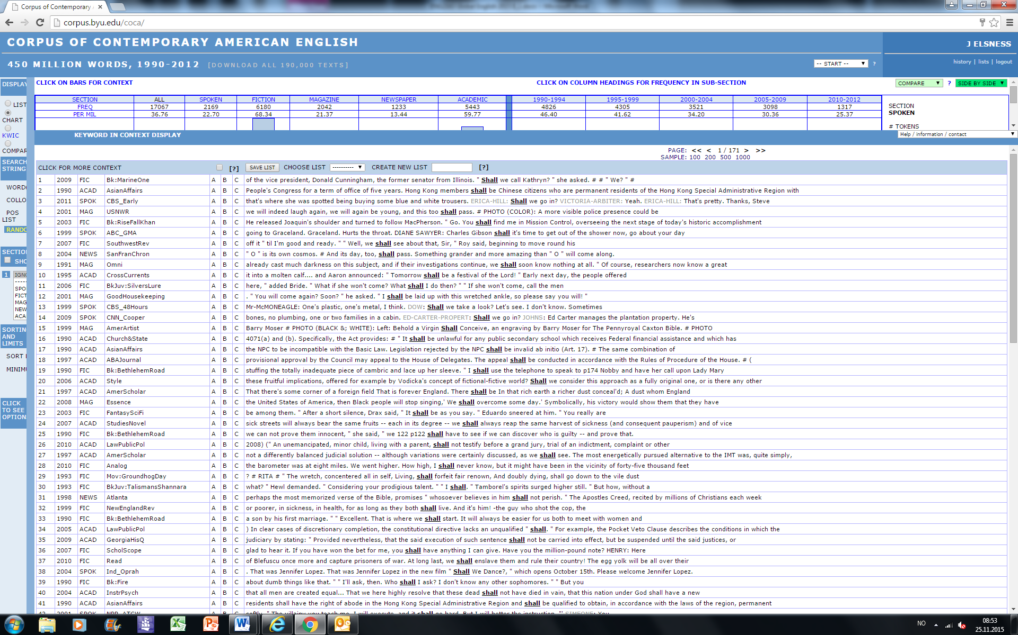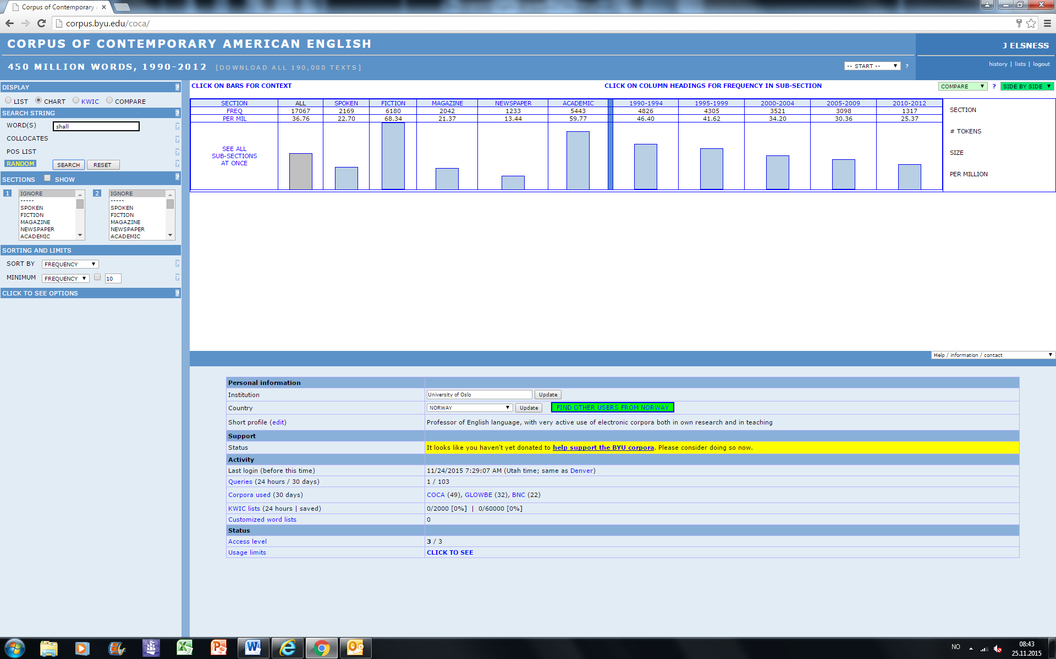
Text provided, no. 2
From Stig Johansson (1979), ‘American and British English grammar: An elicitation experiment’, in English Studies
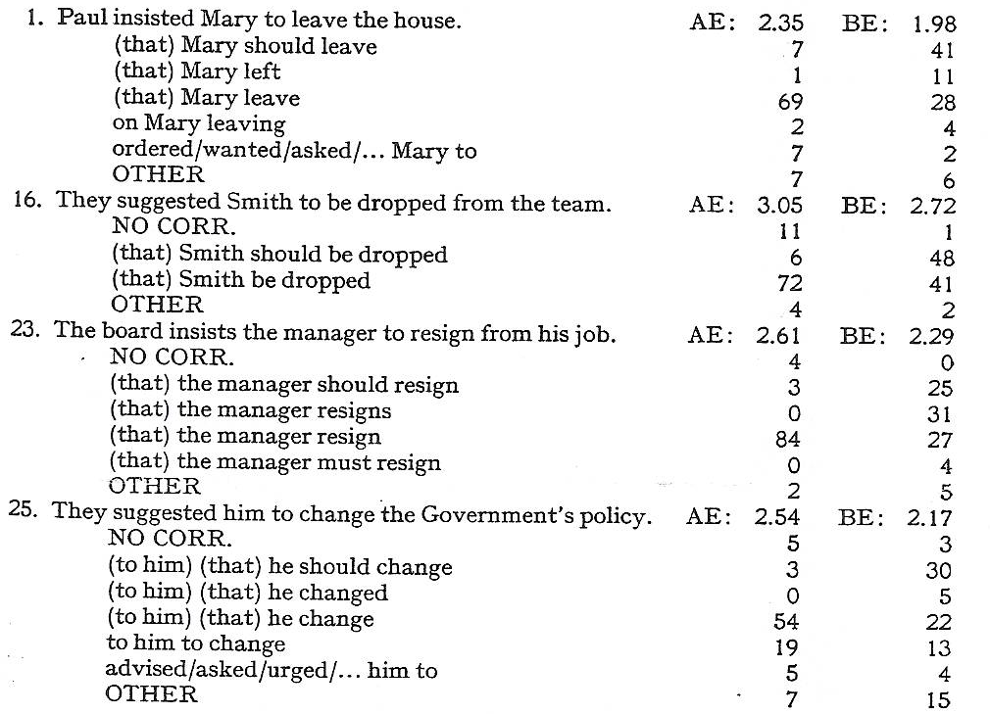
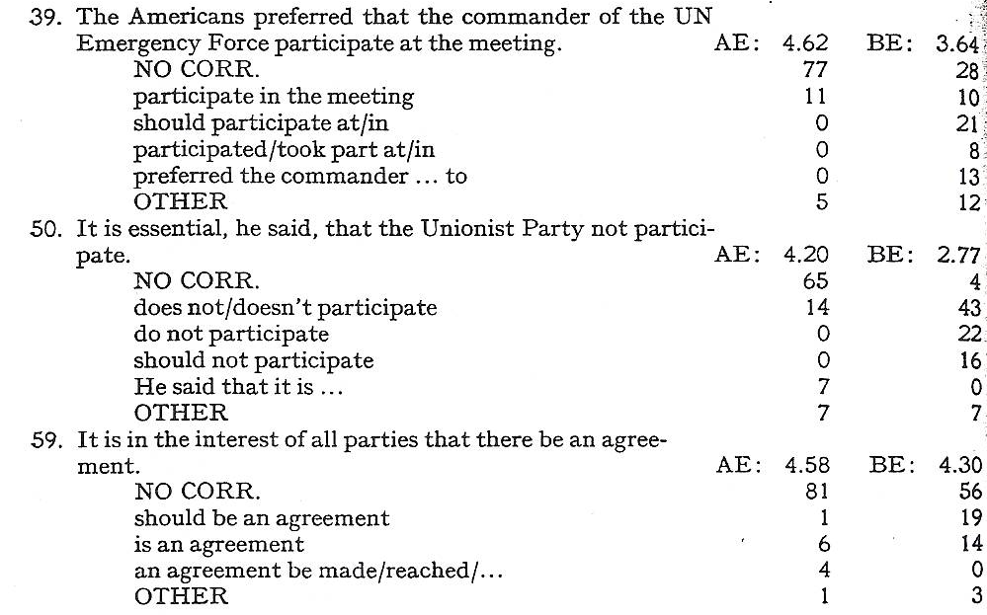

Text provided, no. 3
Table 4 from Peter Collins (2009), ‘The progressive’, in Peter Collins, Pam Peters and Adam Smith (eds.), Comparative Studies in Australian and New Zealand English: Grammar and Beyond

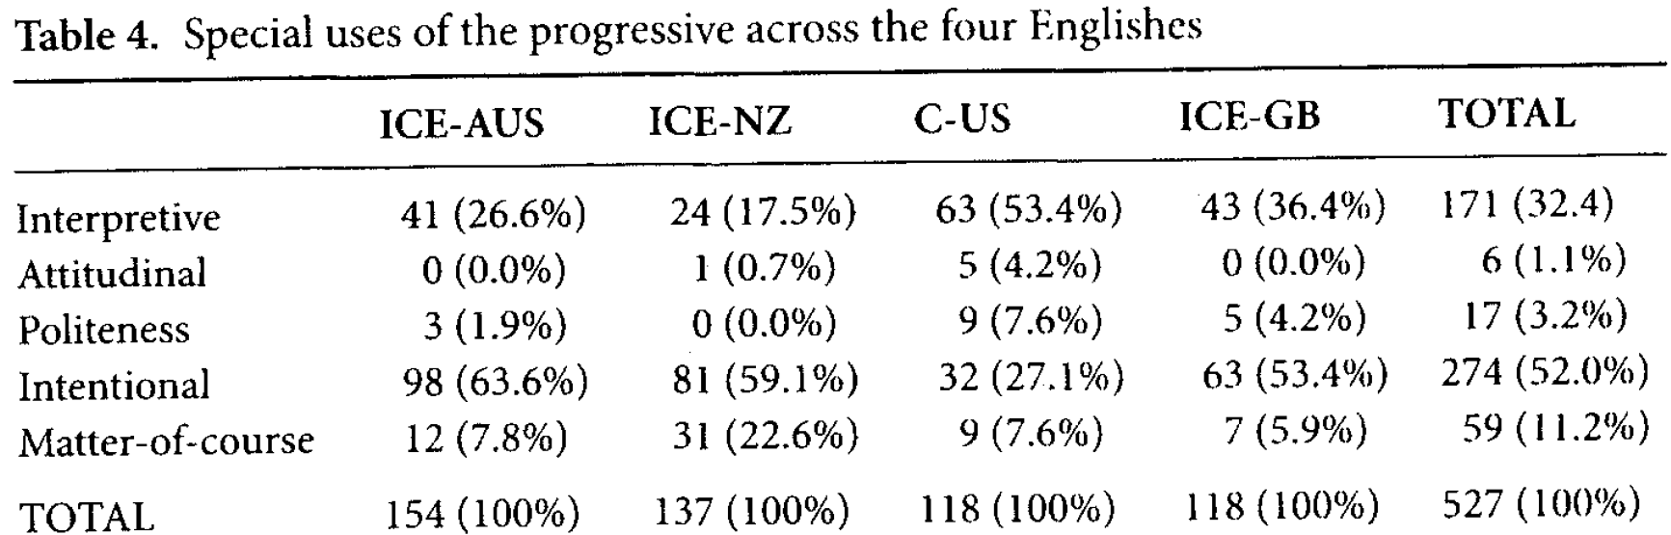

The exam results will be ready in approximately 3 weeks. You will receive an e-mail when the results are ready.

For an explanation of the mark obtained, please contact the teacher responsible for the course within one week after the exam results have been published in StudentWeb. Remember to include your name and candidate number. The examiner will then decide whether to give a written or an oral explanation.

