Evaluation: MEVIT 3300 Media Economics

Summary
Media economics is popular among both Norwegian and international students, and is regarded by the students as a useful and work-relevant course which supplements more theoretical courses touch at the department with a seemingly less relevance for the ”real work-life in the commercial media sector”. In spite of this popularity, the course also has its challenges, not least related to the teaching schedule and the practical rationale behind the intensive teaching because of the visiting professor’s deal with the department, and the delay from last lecture to the exam because of the need to adjust for the students to attend another BA-course in the middle of the semester.

Course content
Media economics is concerned with the changing economic forces that direct and constrain the choices of decision-makers across the media. This course, which is accessible to media students without a background in economics, introduces some of the main economic concepts and issues affecting the media and address some of the more interesting economic characteristics and industrial questions surrounding media corporations and markets. It examines the distinctive economic features of media, the relationship between these features and the strategies deployed by media corporations and a range of key forces and issues affecting the economics of the main sub-sectors of mass media. Areas that will be covered include economics of advertising, print media, broadcasting, film and new digital media.

Course outline
The course was designed according to the week in which visiting professor Gillian Doyle is available for the department, and she gave five lectures over three days, so the teaching was quite intense. Gunn Enli gave two lectures and was the course leader, and thus responsible for the total course outline. In addition, Jens Barland gave a guest lecture based on his recent PhD on the subject.

The seminars were aiming to provide the students with knowledge on the how media economics influences the overarching strategies, and the recent experiences with seeking new sources of (digital) revenues in Norwegian contemporary media companies. We therefore arranged for visits from three companies with different market strategies: Schibsted, HBO Nordic and Viasat. These company visits were used as a step-stone to discuss key concepts in the literature, and to show the relevance of the readings for analysing the contemporary media development.

Teaching
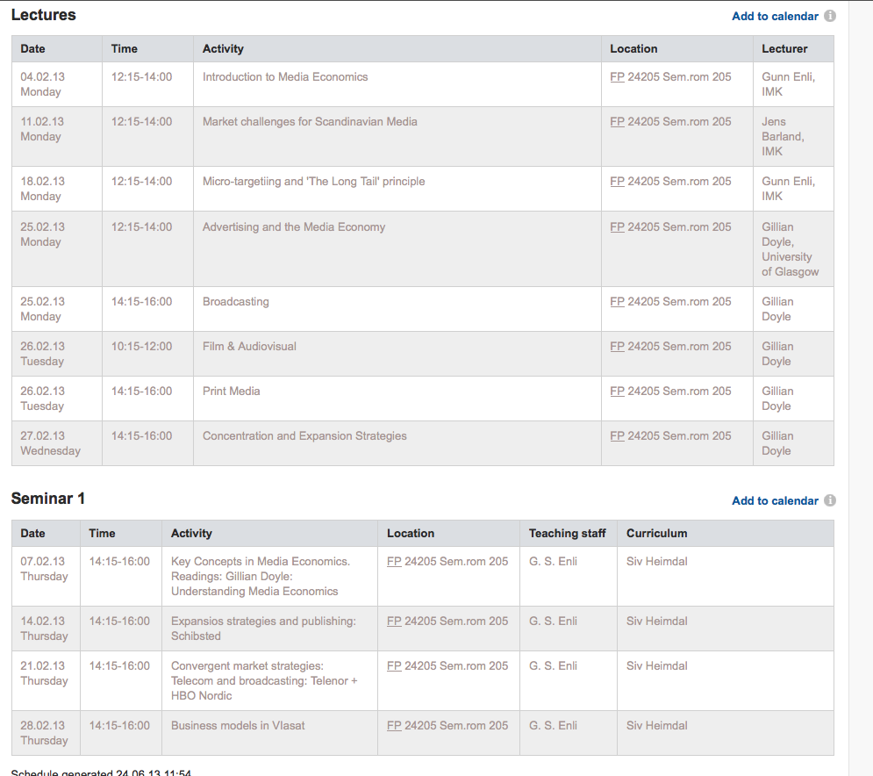

Student evaluations

The students evaluated the lectures from satisfactory (1) quite good (12) very good (8) to excellent (2).

A common positive remark was that the lectures were interesting, informative, with good explanation, and good presentations.

The major criticism was on the timing (‘its stupid to have the lectures a month before the exam – spread them out’)

Doyle was generally praised as a very good teacher, informative and easy to follow, but also ‘very fast’. The guest lecture was commented by several to be weakened by poor English.

The student evaluated the seminars from satisfactory (1) quite good (4) very good (5) to excellent (1).

A common positive remark was the group discussions and the company visits.

The major criticism was lack of time to discuss, and the request for getting tasks in advance.

Reading list
Before the course started, the students complained about too many pages, and as this was a misunderstanding, we thus had a revised version published, and informed the students via e-mail. This was by some seen as confusing, and they would have preferred more consistent and precise information. This could be improved next time.

The readings contain many articles, book chapters, and reports. The students have evaluated the readings as very accessible and interesting. Many students liked Gillian Doyle’s introductory textbook, while some find it too elementary. Also the book is a bit dated, and a new revised version book is expected out soon. This will improve the readings.

Conclusion & Suggestions

The course would benefit from a more coherent time schedule, more regular information to the students, and from more spread-out teaching, and more coherent (and updated) readings, and by making sure the guest lecturers are fluent in English.

Grades

A: 3, B: 5, C: 15, D: 4, E: 3. No Fs

