UNIVERSITY OF OSLO

Faculty of Mathematics and Natural Sciences

Exercise 2b
Explain briefly the function of a CT-scanner, and the two different methods for image reconstruction, preferably with a sketch

- Images taken with continuous x-rays in a spiral around the patient, that means that the tube and/or detectors are rotating while the patient is slowly sent through the scanner. Image information is retrieved from all directions in all planes, and information from the projections is collected with coordinates from the actual positionsl

- Image reconstruction is performed either with filtered back projections or iterative methods.

Filtered back-projections: Scans are back projected for all projections with a high-pass filter to minimize blur

Iterative: Make a qualified quess and try on a model, measure, refine and try one more iteration

Exercise 2c
Why are iterative methods preferred in modern scanner?

- The weakness of filtered back projection is noise, blur and streak artifacts, the strength is speed and light demands for processing capacity
- The weakness of iterative algorithms is time consumption and high demands on processing capacity. The strength is the absence of noise, blur and streak artifacts.

The weakness of the iterative methods will diminish as the processing capacity is increasing

Exercise 2d
What are the main sources of error for a regular x-ray system, and what can you do to minimize them?

- Motion artifacts, keep the patient and equipment steady
- Width of focal source, choose the right one and keep the patient close to

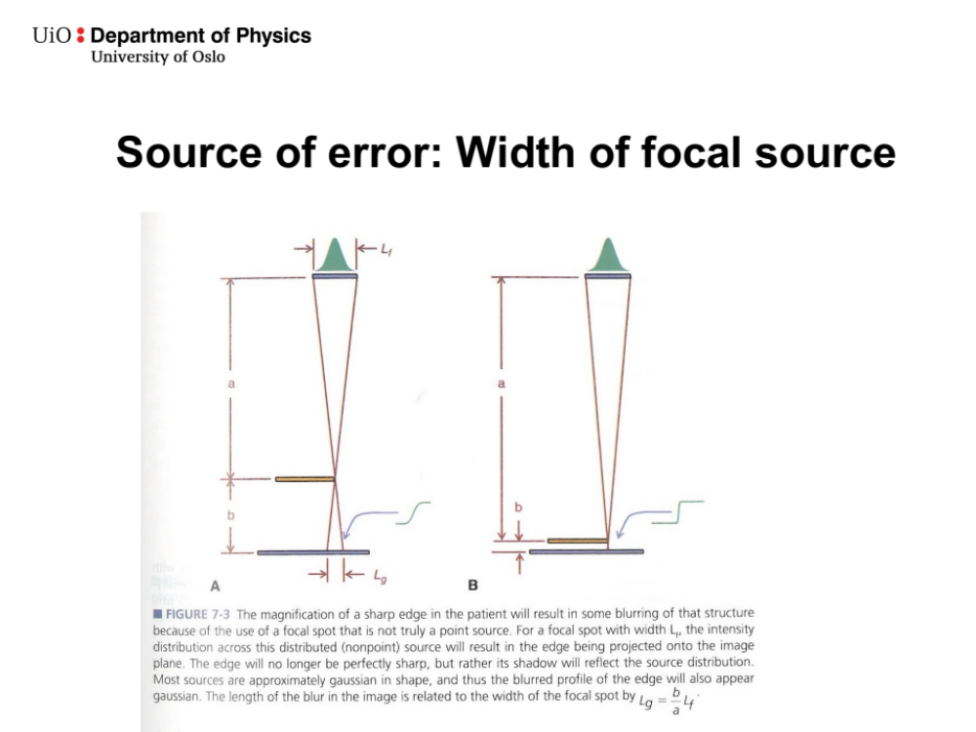
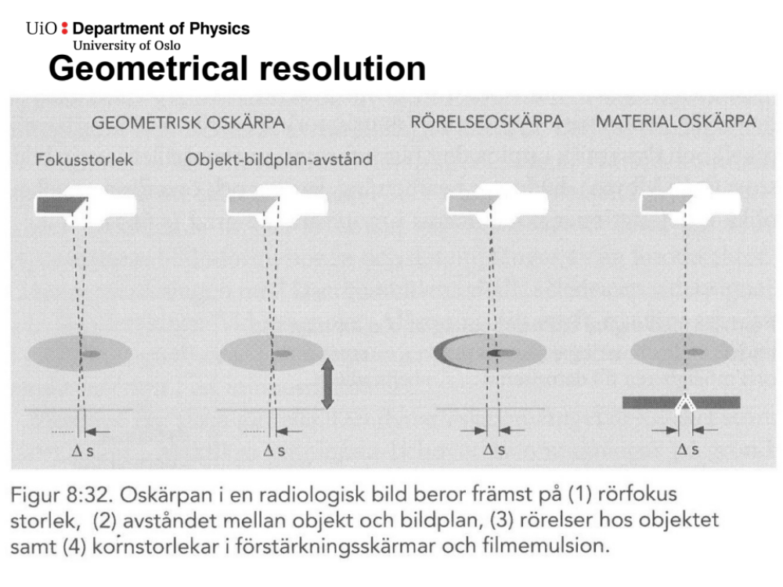

Exercise 2e
What determines the maximum resolution of a CT-image?

- The number of detector elements in the XY-plane (the isolation between the detector elements have the same thickness, when detector elements increase, the same will the area covered by isolation
- The thickness of slices in Z directions
- Focal spot size, mainly by increasing sharpness (you can argue that this is not a part of resolution)
- Reconstruction algorithm, iterative methods tends to have better resolution due to less blur
- Contrast resolution, mainly due to the dose (increased dos will suppress noise and improve contrast
- Bit-resolution in the AD-converter

Exercise 3a
- The cell saver takes blood out from the operating wound together with anticoagulant, filter it, centrifuges it, takes the red blood cells out and reinfuses them into the vein. The rest of the plasma is waste, we don’t want the immune activation factors recycled into the blood vessels.

The bag is used because that avoids injecting air bubbles into the blood vessels

Exercise 3b
Two problems of constant current sensor circuit:
- Time constant of the sensor embedded in the probe is a few tenths of a second, too long for the desired frequency respons of 0 to 25 Hz
- To achieve reasonable sensitivity at high velocities -> high sensor current -> lack of cooling when flow stops -> increased temp (5 deg above body temp) ->fibrin coats the sensor

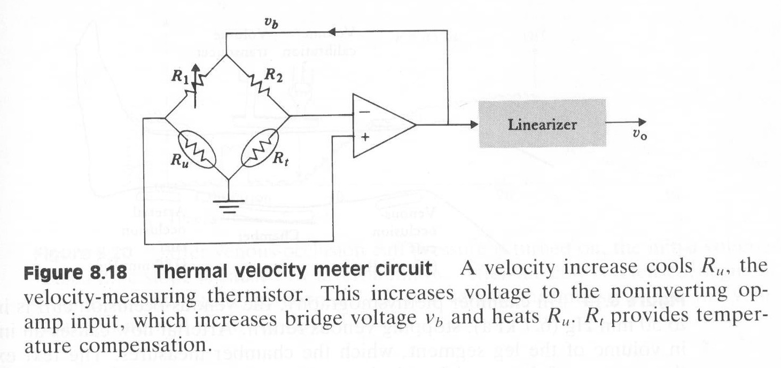

Exercise 3c
There is a risk that the current may follow the electrodes and cables in the ECG-apparatus because the current will always follow the path of least resistance, typically when placed to close to the electrosurgical pen. Place the electrodes distant on the extremities.

Exercise 3d
Light is sent through a thin part of the body, like the finger, and the degree of absorption is measured. By means of Lambert-Beers law, the extinction coefficient is calculated for two different wavelengths: typically, 660 Nm and 930 Nm (red and infrared). By looking at both wavelengths and look up in a table, the belonging level of saturation can be found. By measuring only the pulsatile component, the arterial saturation can be extracted.

Cerebral oximetry lacks the pulsatile component, the blood flow is relatively steady. That’s why you cannot use the pulsatile component

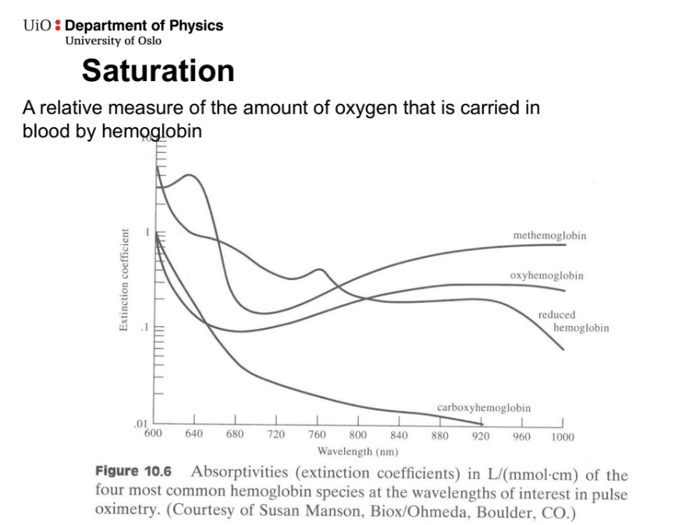

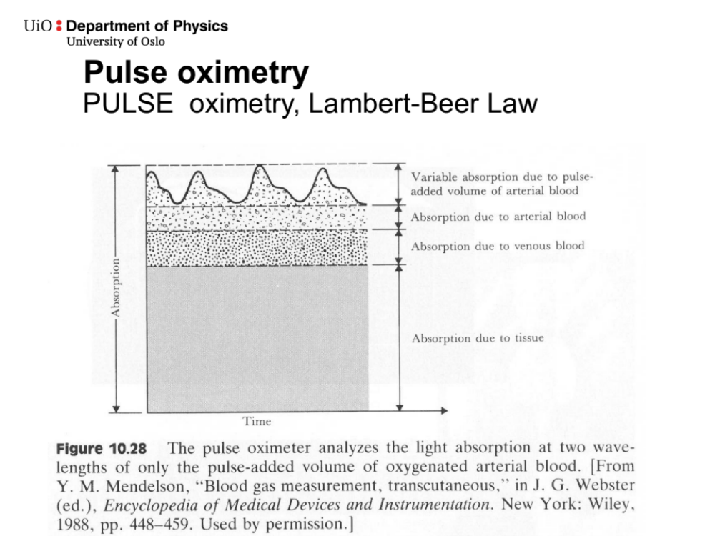

Exercise 3e
- Intrinsic peep occurs when expiratory time is shorter than the time needed to fully deflate the lungs, trapping gas in the lungs
- Could lead to increased pressure and risk of barotrauma, increased intrathoracic pressure and thus decreased venous return, preload and cardiac output
- Can be avoided by extending expiratory time

