Mid-term Exam with sensor guidance, autumn 2026

1.a. What is the origin of an ECG-signal? (You can choose to make a simple sketch)
Answer: It is the summation of all the action potentials in the heart. The student should be able to describe the generation and spread of depolarisation of the membrane and opening of the ion-gates
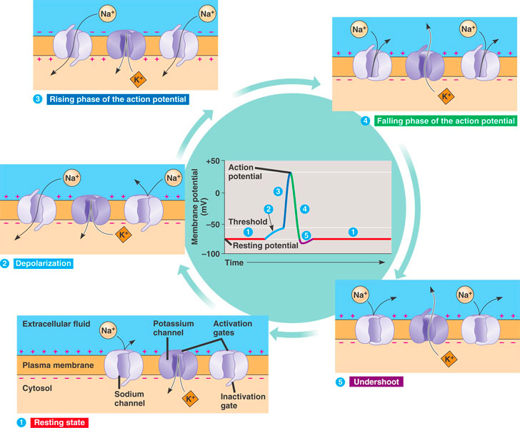

1.b This image shows a commercial ECG-device (source ECG247.com). Which ECG-lead will it show and is this the best position for such a device? (justify your answer)(You can choose to make a simple sketch)

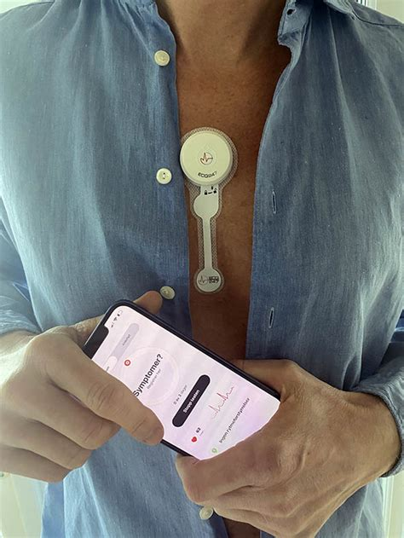

Answer: The electrodes is placed in a vertical line, which means that it is in the same direction as augmented leads aVF (without being an augmented lead) or close to lead II. Both aswers are accepted if they have a simple justifcation. You could argue that it should be slightly tilted to the left for the lowest electrode to fit perfectly to lead II. Lead II is usually used for monitoring because the current (and thus the contraction) is following this path.

1.c Why is it called a monopolar measurement, even if we are using more than one pole? (You can choose to make a simple sketch)

Answer: You can not measure anything electrical with only one electrode. Ideally you should have a reference electrode intinitely far out, but the practitcal solution is to use a variant of Wilson terminal. Then the measurement is focused on one electrode, compared to the reference.

1.d Make a simple sketch of an ECG-signal and describe each of the P,Q,R,S,T-waves (You can choose to make a simple sketch)

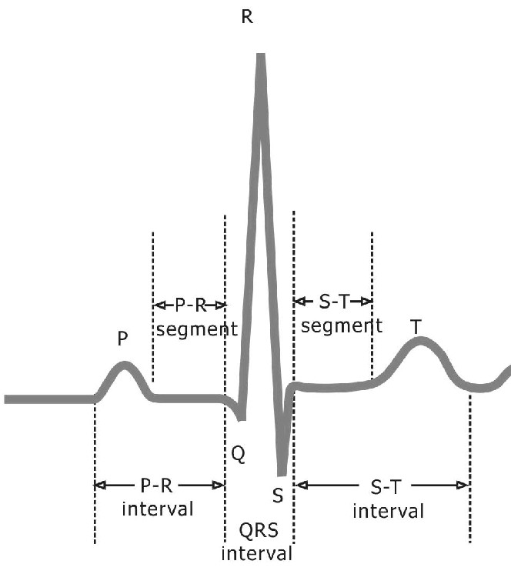
Answer:
P-wave = atrial depolarisation
PR-segment = impulse from atria to ventricles
QRS-complex = ventricular depolarisation
ST-segment = isoelectric – part of repolarisation
T-wave = ususally same direction as QRS – ventricular repolarisation
QT-interval = This interval spans the onset of depolarisation to the completion of repolarization of the ventricles
The ECG-complex

1.e Why is the repolarisation of the ventricles positive, and where is the repolarisation of the atrias in the ECG-curve? (You can choose to make a simple sketch)

Answer: The repolarisation should be negative, but the direction is from the outside in which is the opposite from the depolarisation. The repolarisation of the atria is drowned in the QRS-complex and cannot be seen.

This is the crux of this exam, the student is supposed to be able to resonnate the way to the answer

1.f Describe how to measure cardiac output by means of a pulmonary artery catheter only, and explain why this is the preferred method (You can choose to make a simple sketch)

Answer: If you are limited to use a single catheter without any other means, you will need to use thermodillution. (Ficks method needs an oxygenanalyzer, indicator dye needs a colorimeter). It is cheap, easy to use, not harmful and you can repeat it rapidly.

1.g What mesures can be implemented to counteract signal noise in the ECG-signal? (You can choose to make a simple sketch)

Answer: Faraday cage, amplifiers with high CMRR, and driven right leg.

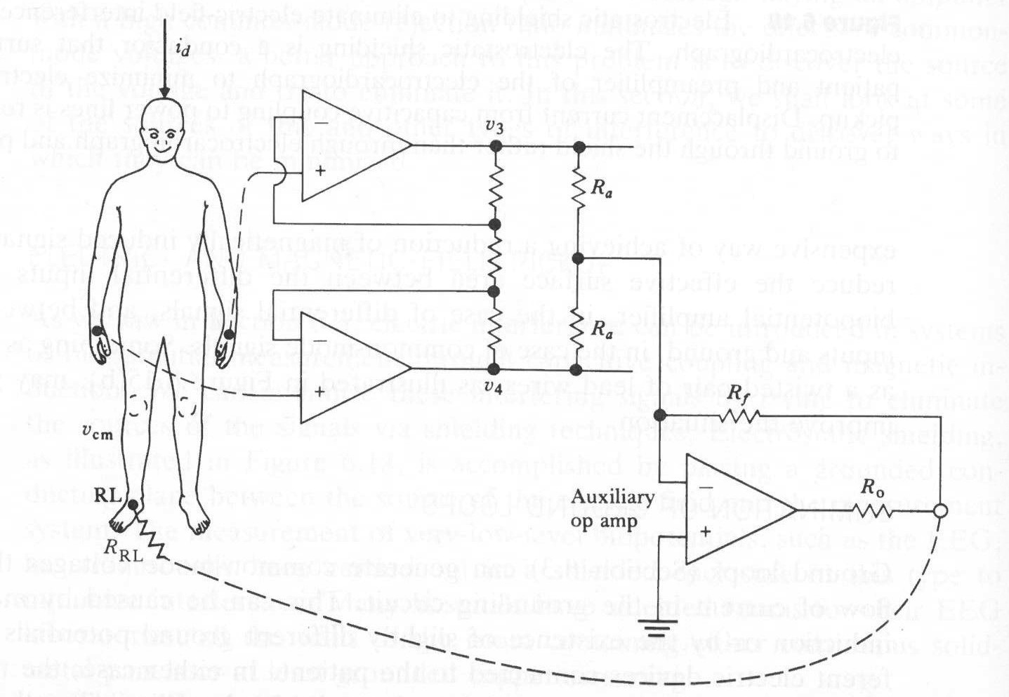

2.a Describe an X-ray tube with a short explanation on how it works (You can choose to make a simple sketch)

Answer:
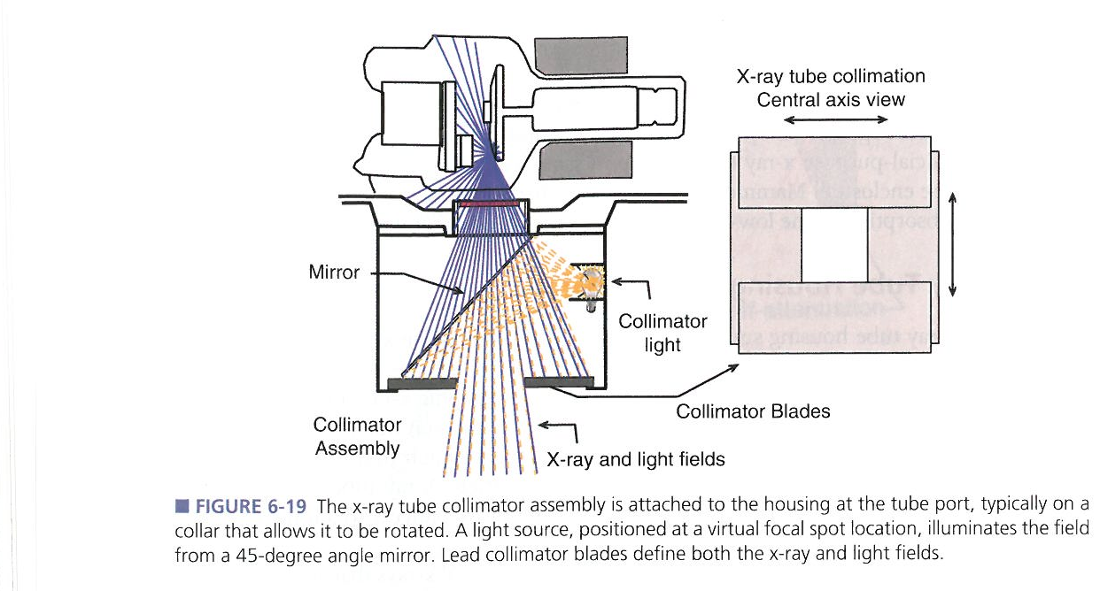

An electron-gun is sending electrons with high energy into a rotating anode disc. This will release energy, either from deceleration of electrons (bremsstralung) or knock electrons of the shell (characteristic radiation)

2. b Explain briefly why the size of the focal source can blur the image (You can choose to make a simple sketch

Answer: 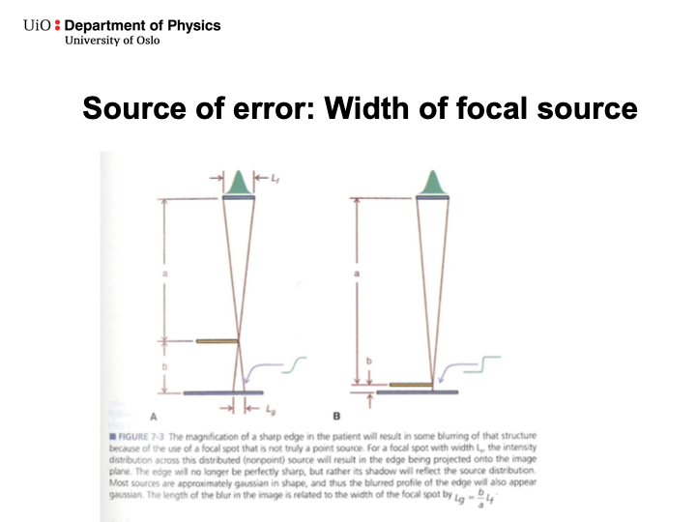

2.c Explain briefly why the CT-tube is different from the regular X-ray tube (You can choose to make a simple sketch)

Answer: Two manin changes.
- Oil Cooling
- Flying focal spot

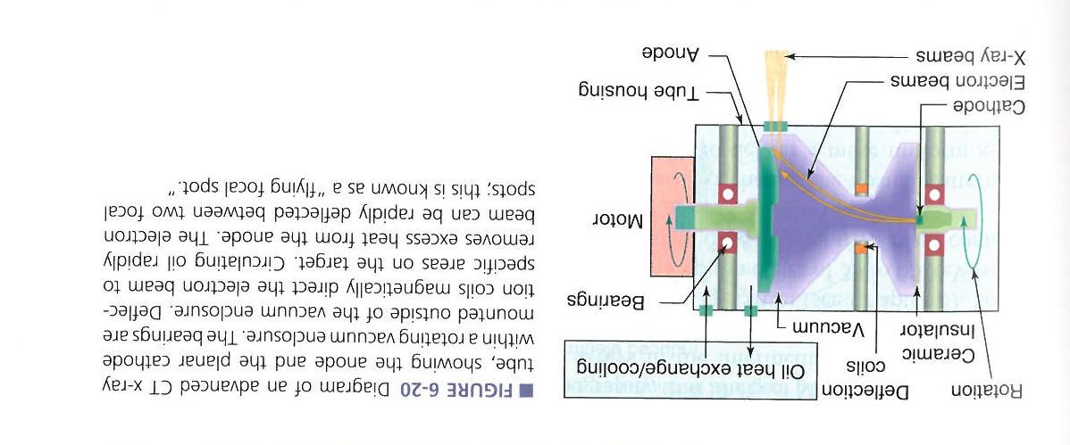

2.d Why can an iterative CT-scanner give sharp images with a lower dose than traditional back-projection CT-scanners? (You can choose to make a simple sketch)

Answer: It is a more effective use of the image information due to the initial guess of the image object, and thus the smart fitting of the model. Filtered back-projecten needs more images in order to reduce the effect of blur

3.a What are the most important safety mechanisms in modern hemodialysis? (You can choose to make a simple sketch)

Answer:

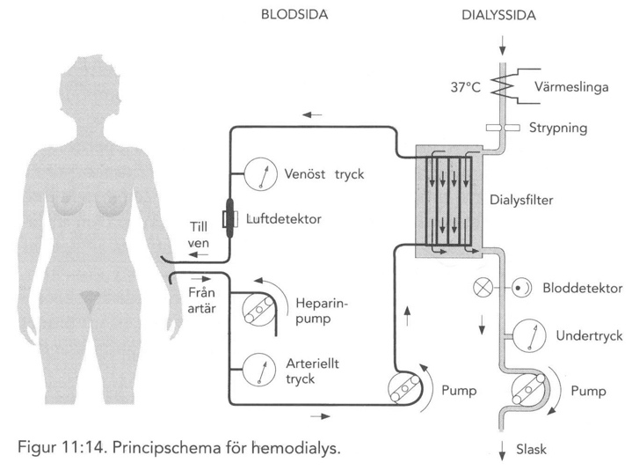
Underpressure on the right side will evacuate blood if a hole appears instead of dialysis liquid leaking into the blood return. Heparin is inserted to avoid clotting, blood is heated to avoid cooling of the patient, both venous and arterial pressure are measured, an an airbubble detector to avoid air-embolism.

3. b One of the main problems with the electromagnetic flowmeter is the transformer voltage. What is the cause of this voltage (briefly)? (You can choose to make a simple sketch)

Answer: We use AC-current to generate a fluctuating magnetic fiels (for many reasons). The problem is that this alternating magnetic field is not only inducing a current as a result of the blood flowing it is also inducing current in the electrodes and cables directly as long as they are not perfectly orthogonal. The same fluctuating magnetic field also enables phase-sensitiv detection and effective electronic separation of the flow signal from the rest of the aquired signals (quadrature suppression)

3.c Make a simple sketch of a servocontrolled ventilator and explain briefly how this ventilator can be able to maintain a PEEP in the lungs of the patient (You can choose to make a simple sketch)

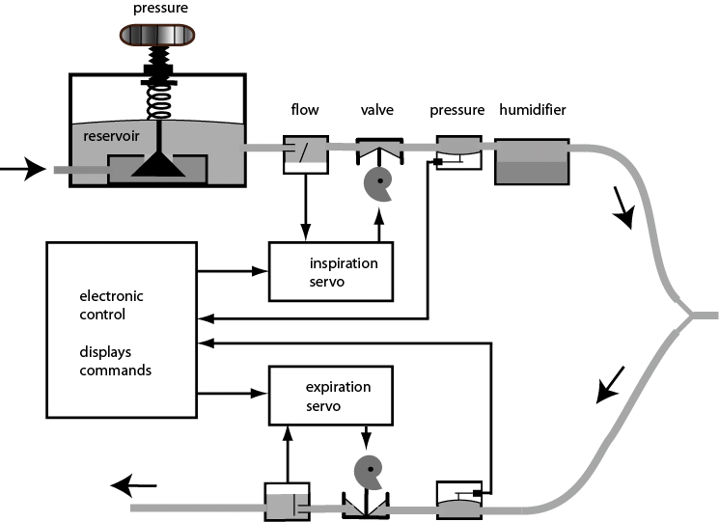

Answer: The expiration servo can (by means of the expiration valve) cut the expiration flow at a certain pressure, in order to keep the lungs open (Positive end expiratory pressure)

3.d High common mode rejection ratio (CMRR) is important to surpress common mode voltage when measuring something on the body with electrodes. Give an example of a scenario where common mode voltage can still introduce noise into the system, despite a high CMRR (You can choose to make a simple sketch)
Answer: The little crux of the exam. The prerequisite for CMRR-suppression is that the signal is the same on both inputs. If they are not, the common mode is transformed to a differential signal that will not be trapped by the CMRR. This could be caused of:

- unequal electrode-skin impedances
- unequal cable impedances
- asymmetric capacitive coupling
- component tolerances
- imperfect electrode placement

