**UNIVERSITETET I OSLO**

**Det matematisk-naturvitenskapelige fakultet**

**Exam in: MBV4230 - 9230 Eukaryotic transcription factors**

**–** structures, function, regulation

**Day of exam:. Wednesday 25 May 2011**

**Exam hours: 09.00 – 12.00**

**This examination paper consists of 4 pages.**

**Permitted materials: None**

*Make sure that your copy of this examination paper*

*is complete before answering.*

All questions are given in English, but you may choose yourself in which language (Norwegian or English) you prefer to answer. This exam consists of two parts. The first part is a set of questions, where you are supposed to provide brief and concise answers through a few phrases only (less than 10 phrases). The second part consists of questions that may require slightly more elaborate answers, although you should still try to keep the text volume limited and the style concise.

Part I: Short questions

a) The general transcription factors will together with RNA polymerase II (RNAPII) assemble in a specific order to form the pre-initiation complex. Specify this order by filling in numbers in the table below.

|  |  |
| --- | --- |
| **GTF** | **Order (1,2…etc**) |
| TFIIA |  |
| TFIIB |  |
| TFIID |  |
| TFIIE |  |
| TFIIF |  |
| TFIIH |  |
| RNAPII |  |

b) How does TFIIB interact with promoter DNA?

c) List and briefly explain the enzymatic activities associated with TFIIH.

a) Specify three core promoter elements that are recognized by the TAF complex TFIID.

b) The Mediator complex may exist in three distinct forms. Describe briefly the differences between these forms and their function.

c) The Mediator is mostly associated with gene activation, but not exclusively. How does the Mediator function in repression?

a) DNA methylation has been correlated with transcriptional silencing. Several mechanisms for how DNA methylation inhibits transcription have appeared. Briefly explain at least three such mechanisms.

b) List and briefly define the different HDAC families. Give a short comment on their specificity.

c) One of the HDAC families is ubiquitously expressed in the body – which one?

a) The elongation phase of transcription by RNAPII can be divided into different stages. Give a brief description of the different stages (A-E) illustrated in the figure below, including the names of the different proteins shown as ovals without names.

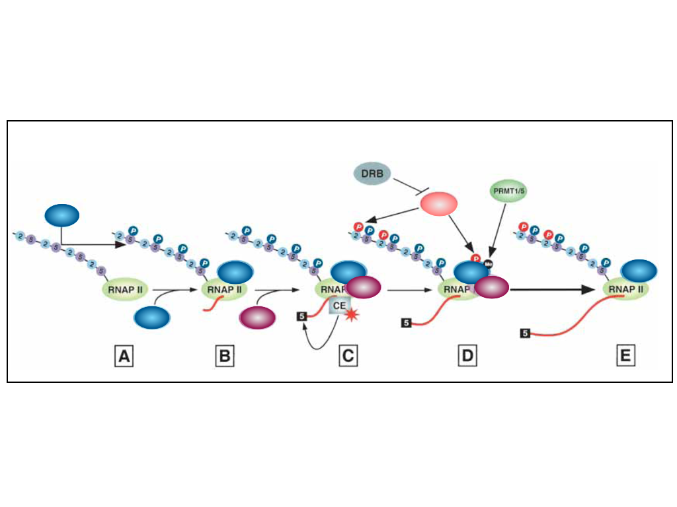

b) Another kinase than the ones shown in the figure is also capable of phosphorylating RNAPII CTD on Ser5. Give the name of this kinase, and describe briefly the functional consequence of its action.

c) Explain what DRB (seen in the figure) is.

d) How does TFIIS help RNAPII to recover from an arrested state and resume elongation?

a) Chromatin Conformation Capture methods (3C, 4C, etc) are used to measure long-range chromatin interactions. Explain what *interchromosomal* and *intrachromosomal* interactions mean. Which of the different Capture methods can be used to measure *interchromosomal* interactions?

b) How does the nuclear lamina affect gene expression?

c) What are LADs?

d) What technique is used to define LADs? Briefly explain the basic principles of this technique.

Nuclear receptors comprise the largest family of metazoan transcription regulators. These proteins share a common structural design. Indicate the names and functions of of the different domains illustrated below, and briefly describe the function of three of them.



A/B domain:

C-domain:

D-domain:

E-domain:

F-domain:

Tyrosine phosphorylation is a critical event in the JAK-STAT pathway. Briefly describe the steps of the pathway in which tyrosine phosphorylation is an important element for the events to occur.

Part II: Full questions

# A

RNAPII is the key enzyme in the process of transcription.

Describe briefly the overall structural design of RNAPII including some key regions and channels in the enzyme and their function. Then explain how the following three specific processes occur:

1. The addition of a new nucleotide at the growing end of the RNA chain.
2. The melting of the DNA-RNA hybrid after the first few nucleotides have been added.
3. Abortive initiation.

# B

Transcription factors are able to recognize specific sequences in DNA and bind to these. What are the principles of this sequence recognition? Use homeodomains and zinc finger proteins as examples to illustrate the principles.

# C

Several transcription factors are endpoints of signalling pathways being responsible for turning on a set of downstream target genes. Normally, such pathways and the gene programs that have been turned on, have to be turned off again after the signalling event is over. One mechanism is to have the “shut-off” process mediated by specific downstream target genes. Explain two examples of this principle using different families of transcription factors as examples.

# 