Task 1
Combine important names with publications
Fumifugum – John Evelyn
Our Common Future – Gro harlem Brundtland
Silent Spring – Rachel Carson

Task 2
Briefly describe what is meant by the terms:
1. Pollution
Pollution is the introduction of contaminants that inflicts damage to the environment
Pollution can be in the form of dangerous chemicals, noise and heat or light
2. 'Rebound' effect
The reduction in expected gains from new technologies that increase the efficiency of resource use, because of behavioral or other systemic responses
3. Energy Intensity
Measure of energy efficiency. Ratio between overall energy requirements and GDP so that low number indicates good energy efficiency
4. Exergy
The quality of the energy. Energy forms with high exergy can be used to do work before it is transformed to heat (energy with low exergy)
5. Energy Reserves and energy Resources
Energy reserves are energy resources that are possible and economic feasible to recover
Task 3:
Combine pie chart showing the distribution of primary energy sources with the right connection.

WORLD

GERMANY

NORWAY

CHINA
Task 4
Combine the distribution of energy between different religions in the figures above with the year they pertain to in the table below
1965
1985
2011

Task 5
The graphs show the production of hydropower, wind, solar and geo-thermal over time in different regions.
Combine graph with correct renewable energy source in the table.

Water

Wind

Sun

Geo

Task 6
Give a brief account (maximum 8 sentences) of the four main challenges associated with the use of renewable energy sources. Which is the main problem for a country like Germany?
Production cannot be adjusted in relation to consumption.
The energy will be too expensive to produce.
The total environmental impact of harvesting of renewable energy is unclear
The plants take up too much space
Not enough capacity to cover the existing and future demand

Task 7
Describe three physical or chemical effects that dissolved natural organic material (DNOM) has on the environment and the environmental problems it causes. Maximum 6 sentences total.
Increased:
- Mobilization of heavy metals and POP
- Flux of nutrients
- Absorption of light
Effect on
- Increased pollutants (e.g. Hg) in freshwater fish
- Eutrophication
- Changed temperature gradients causing changes to lake stratification
- Changes in Trophic levels

Task 8
Connect chemical substance with site where the accident occurred
Bhopal, India – Methyl isocyanate
Minamata, Japan – Mercury
Seveso, Italy - Dioxin

Task 9
Environmental measures often have unintended effects.
Connect environmental initiatives with appropriate negative side effect
Proliferation of mercury – Energy saving bulbs
Emission of NOx – Diesel cars
Emission of nitramines - Carbon capture
Increased Eutrophication – Decline in acid rain
Increased acidification – Removal of particles from fluegasses

Task 10
Write briefly (1-6 sentences) about mercury (Hg) as an environmental problem.
Make sure to include the following aspects:
1. How Hg is transported in the environment?
2. Where Hg accumulates in the environment?
3. Why Hg accumulates in this (i.e. answer to Q 2) compartment?
Mercury as ⁰Hg is long range transported with air masses by global distillation. It continuously condenses and evaporates until it reaches a cold environment where it does not re-evaporate. The Hg therefore accumulates in cold places, such as the polar regions and in high mountains. Hg species are strongly bound to organic matter. It therefore also accumulates in the organic rich forest floor horizon and in sediments in the boreal zone. It is washed out with DNOM and is bio-concentrated into the food chain as methyl Hg produced by sulfur reducing bacteria. In living material the methyl-Hg is bound to the SH-groups in proteins and is biomagnified through the food chain. High levels of Hg are therefore found in old and fat fish causing dietary advice.

Task 11
Errors and defects with potable water and sewage pipelines are causing major problems for sewage treatment facilities and the discharge of pollutants to the environment.
Describe the three major errors. Maximum 6 sentences.
- Leakage from water production to consumer (42%) into sewage system (2/3)
- Inflow of storm and drainage water, streams and groundwater.
- Losses due to leakages and sewage overflows. This is increasing due to climate change and more impermeable surfaces
This is causing the sewage to be diluted and more difficult to clean as well as capacity problems in the waterworks during storm flow
Task 12
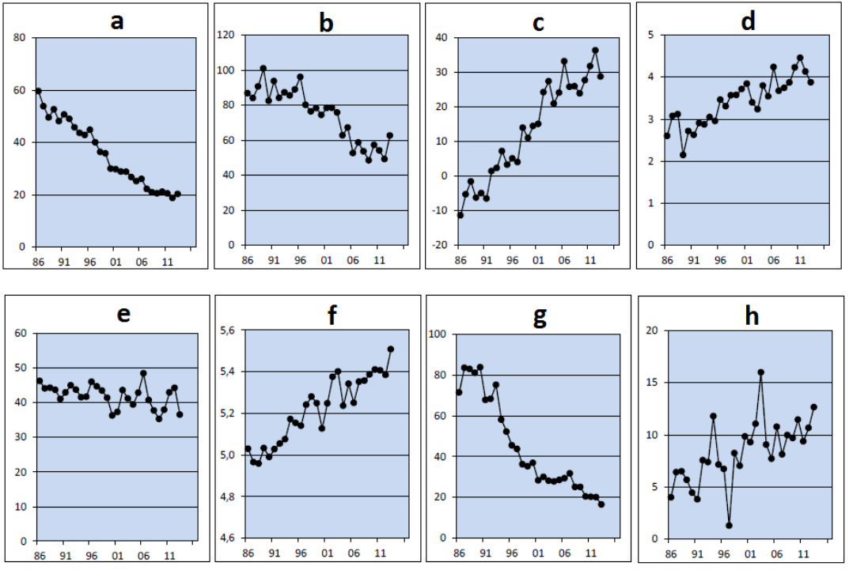Allocate the chemical parameters below to the correct graph above.
Note the scale on the y-axis in addition to the trend
 | ANC | TOC | Sulphate | Nitrate | Labile Aluminium | pH | Sodium | Calcium + magnesium
 | µeq/L | mg/L | µeq/L | µeq/L | µg/L |  | µeq/L | µeq/L
A |  |  | X
B |  |  |  | X
C | X
D |  | X
E |  |  |  |  |  |  |  | X
F |  |  |  |  |  | X
G |  |  |  |  | X
H |  |  |  |  |  |  | X

Task 13
Combine environmental Challenge with the pollutant that it is mainly related to.
PO4 – Aquatic eutrophication
CO2 – Global warming
SO2 – Smog
Hg – Accumulation in Artic
Parabens – Coctail effect

Task 14
Combine each environmental challenge with the pollutant that it is mainly related to.
SO2 – Soil acidification
CO2 – Marine acidification
Heavy metals – Bioaccumulation
POP - Bioaccumulation

Task 15
Combine compound shown in the sphere model with correct pecticide in the table

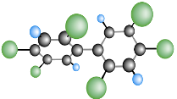
PCB
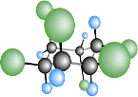
HCH
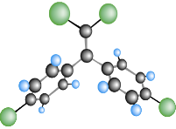
DDE
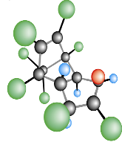
Chlordane
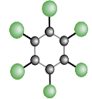
HCB
Task 16
Combine name of radiation type with the right figure
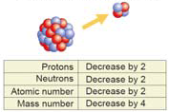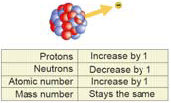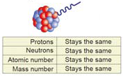
Alfa Beta Gamma

Task 17

Which source of radiation gives, on average, the highest radiation dose to people in Norway (tick one alternative)?
X Radon
Radiation use in health care
Radioactive contamination
Natural radioactivity in the body
Radiation from space
Natural external radiation from the environment
Select the two sources contributing the least as radiation sources to people in Norway (tick two alternatives).
Radon
Radiation use in health care
X Radioactive contamination
Natural radioactivity in the body
X Radiation from space
Natural external radiation from the environment

Task 18
Compare Chernobyl and the Fukushima accident. Among other things include which of the accidents led to the most damage, which substances and what amount of radioactivity were released, and where in the environment most of the emissions ended up. Maximum 12 sentences.
Answer:
The cause for the Chernobyl and Fukushima disaster was human error in the former and natural disaster for the latter.
Damage: In almost every respect, the consequences of the Chernobyl accident clearly exceeded those of the Fukushima accident. Releases from the Chernobyl accident also included those radionuclides with very short half‐lives in the range of seconds and minutes that are characterized by enormous specific activities. This led to the massive radiation damage in the so‐called “Red Forest”, where pine trees succumbed due to radiation‐induced destruction of plant tissue in the early aftermath of the accident. The Chernobyl disaster caused widespread dispersion of radioactive nuclides/particles with the wind to major parts of the European mainland, while most of the radioactive particles released at Fukushima was bound in the local area or leached into the sea.
Evacuation at Chernobyl began 3–11 days after the accident, which was already late for parts of the affected population. Both the highly contaminated areas and the evacuated areas are smaller around Fukushima and the projected health effects in Japan are significantly lower than after the Chernobyl accident. In contrast to Chernobyl, no fatalities due to acute radiation effects occurred in Fukushima.

Which substances: In both accidents, most of the radioactivity released was due to volatile radionuclides (noble gases, iodine, cesium, tellurium). The most obvious difference between both accidents is the presence or absence of refractory elements such as plutonium or semi‐volatile 90Sr in the environment samples. Many reports on semi‐volatile 103,106Ru and refractory radionuclides (95Zr, 140La, 141,144Ce, etc.) in air and other media have been published after Chernobyl, but hardly any after Fukushima. Even reports on radionuclides of semi‐volatile elements such as Strontium from Fukushima are still rare

Amount of radioactive material released:
○ Chernobyl: 5300 PBq (excluding noble gases) was released
○ Fukushima: 520 PBq.
However, the amount of refractory elements (including actinides) emitted in the course of the Chernobyl accident was approximately four orders of magnitude higher than during the Fukushima accident
Where: In the Fukushima accident the majority of the radionuclides (more than 80%) was transported offshore and deposited in the Pacific Ocean. Both the Chernobyl and Fukushima accidents caused radionuclide contamination of the atmosphere, hydrosphere, biosphere and pedosphere over the entire northern hemisphere.
Chernobyl's “exclusion zone” initially encompassed a 30 km radius (2800 km2) around the NPP. Approximately 116000 people within the “exclusion zone” were evacuated to less contaminated areas in the months following the accident. Later, the exclusion zone was extended and covered 4300 km2 in 1996, in order to contain the areas with the highest radiation levels. More than 90% of the radiostrontium and radioruthenium activities at Chernobyl were emitted in fuel particle form. In contrast, at Fukushima gas phase emissions clearly dominated the releases.

